Higher Nationals - Summative Assignment Feedback Form

|  |  |  |  |  |  |
| --- | --- | --- | --- | --- | --- |
|  | | | | | |
|  |  |  |  |  |  |
|  | | | | | |
|  |  |  |  |  |  |
|  | | | | | |

|  |  |  |  |
| --- | --- | --- | --- |
| **Student Name/ID** | H.Menuka Sankalpa Deshapriya / E018689 | | |
| **Unit Title** | **45: Internet of Things** | | |
| **Assignment Number** | **1** | **Assessor** | Mr.Nisal Thalpawila |
| **Submission Date** |  | **Date Received 1st submission** |  |
| **Re-submission Date** |  | **Date Received 2nd submission** |  |
| **Assessor Feedback:**  **LO1 Analyse what aspects of IoT are necessary and appropriate when designing software applications**  **Pass, Merit & Distinction P1 P2 M1 M2 D1 Descripts**  **LO2 Outline a plan for an appropriate IoT application, using common architecture, frameworks, tools, hardware and APIs**  **Pass, Merit & Distinction P3 P4 M3 M4 Descripts**  **LO3 Develop an IoT application using any combination of hardware, software, data, platforms and services**  **Pass, Merit & Distinction P5 P6 M5 D2 Descripts**  **LO 4 Evaluate your IoT application and the problems it might encounter when integrating into the wider IoT ecosystem**  **Pass, Merit & Distinction P7 P8 M6 D3 Descripts** | | | |

|  |  |  |
| --- | --- | --- |
| **Assessor Feedback:**  **\*** | | |
|  |  |  |
| **Resubmission Feedback:**  **\*Please note resubmission feedback is focussed only on the resubmitted work** | | |
|  |  |  |
| **Internal Verifier’s Comments:** | | |
| **Signature & Date:** | | |

* Please note that grade decisions are provisional. They are only confirmed once internal and external moderation has taken place and grades decisions have been agreed at the assessment board.

**Pearson Higher Nationals in**

Computing

45: Internet of Things Assignment 01 of 01

**General Guidelines**

1. A Cover page or title page – You should always attach a title page to your assignment. Use the previous page as your cover sheet and make sure all the details are accurately filled.
2. Attach this brief as the first section of your assignment.
3. All the assignments should be prepared using word processing software.
4. All the assignments should be printed on A4-sized papers. Use single-sided printing.
5. Allow 1” for the top, bottom, and right margins and 1.25” for the left margin of each page.

**Word Processing Rules**

1. The font size should be **12** points and should be in the style of **Time New Roman**.
2. **Use 1.5 line spacing**. Left justify all paragraphs.
3. Ensure that all the headings are consistent in terms of font size and font style.
4. Use the **footer function in the word processor to insert Your Name, Subject, Assignment No, and Page Number on each pag**e. This is useful if individual sheets become detached for any reason.
5. Use word processing applications spell check and grammar check functions to help edit your assignment.

**Important Points:**

1. It is strictly prohibited to use textboxes to add texts to the assignments, except for the compulsory information. eg: Figures, tables of comparison, etc. Adding text boxes in the body except for the before mentioned compulsory information will result in the rejection of your work.
2. Avoid using page borders in your assignment body.
3. Carefully check the hand-in date and the instructions given in the assignment. Late submissions will not be accepted.
4. Ensure that you give yourself enough time to complete the assignment by the due date.
5. Excuses of any nature will not be accepted for failure to hand in the work on time.
6. You must take responsibility for managing your own time effectively.
7. If you are unable to hand in your assignment on time and have valid reasons such as illness, you may apply (in writing) for an extension.
8. Failure to achieve at least PASS criteria will result in a REFERRAL grade.
9. Non-submission of work without valid reasons will lead to an automatic RE FERRAL. You will then be asked to complete an alternative assignment.
10. If you use other people’s work or ideas in your assignment, reference them properly using the HARVARD referencing system to avoid plagiarism. You have to provide both in-text citations and a reference list.
11. If you are proven to be guilty of plagiarism or any academic misconduct, your grade could be reduced to A REFERRAL, or at worst you could be expelled from the course.

**STUDENT ASSESSMENT SUBMISSION AND DECLARATION**

When submitting evidence for assessment, each student must sign a declaration confirming that the work is their own.

|  |  |  |  |
| --- | --- | --- | --- |
| H.Menuka Sankalpa Deshapriya / E018689 | | Assessor name: Mr.Nisal thalpawila | |
| Issue date: | Submission date: | | Submitted on: |
| Programme: internet of things | | | |
| Unit: 45 | | | |
| Assignment number and title: | | | |

**Plagiarism**

Plagiarism is a particular form of cheating. Plagiarism must be avoided at all costs and students who break the rules, however innocently, may be penalised. It is your responsibility to ensure that you understand correct referencing practices. As a university level student, you are expected to use appropriate references throughout and keep carefully detailed notes of all your sources of materials for material you have used in your work, including any material downloaded from the Internet. Please consult the relevant unit lecturer or your course tutor if you need any further advice.

**Guidelines for incorporating AI-generated content into assignments:**

The use of AI-generated tools to enhance intellectual development is permitted; nevertheless, submitted work must be original. It is not acceptable to pass off AI-generated work as your own.

**Student Declaration**

**Student declaration**

I certify that the assignment submission is entirely my own work and I fully understand the consequences of plagiarism. I understand that making a false declaration is a form of malpractice.

Student signature: [menuka.sankalpa@gmail.com](mailto:menuka.sankalpa@gmail.com)

Date:

**Higher National Diploma in Business**

Assignment Brief

|  |  |
| --- | --- |
| Student Name /ID Number | H.Menuka Sankalpa Deshapriya / E018689 |
| **Unit Number and Title** | **45: Internet of Things** |
| Academic Year | 2022/2023 |
| Unit Tutor | Mr.Nisal |
| **Assignment Title** | Researching and building an IoT application |
| Issue Date |  |
| Submission Date |  |
| IV Name & Date |  |

|  |
| --- |
| **Submission format** |
| The assignment submission is in the form of:   * **a case study** on a positive example of an Internet of things (IoT) implementation with a recommended word limit of 1,000–1,500 words, written in a concise style, although you will not be penalised for going under, or exceeding, the total word limit * **a project plan and development report** on the development of an appropriate IoT application with a recommended word limit of 2,000–2,500 words, written in a concise style, although you will not be penalised for going under, or exceeding, the total word limit * **a project report** evaluating the success of your final IoT product with a recommended word limit of 1,000–1,500 words, written in a concise style, although you will not be penalised for going under, or exceeding, the total word limit.   You are required to make use of headings, paragraphs, and sub-sections as appropriate, and all work must be supported with research and referenced using the Harvard referencing system (or an alternative system). You will also need to provide a bibliography using the Harvard referencing system (or an alternative system). Inaccurate use of referencing may lead to issues of plagiarism  if not applied correctly. |

|  |  |
| --- | --- |
|  | **Unit Learning Outcomes:** |
|  | LO1 - Analyze what aspects of IoT are necessary and appropriate when designing software applications.  LO2 - Outline a plan for an appropriate IoT application, using common architecture, frameworks, tools, hardware, and APIs.  LO3 - Develop an IoT application using any combination of hardware, software, data, platforms, and services.  LO4 - Evaluate your IoT application and the problems it might encounter when integrating into the wider IoT ecosystem. |

|  |  |
| --- | --- |
|  | **Assignment Brief and Guidance:** |
|  | **Scenario**  ‘***ChannelCert (PVT) Ltd***’ is a leading research and consultancy firm researching new market trends In the IT industry and IoT applications for corporate clients and the consumer market. You currently work as a junior infrastructure architect for ***’ChannelCert (PVT) Ltd***’. As part of your role, your manager has tasked you to conduct research on Internet of Things applications and technologies in order to enlighten a new intake of probationary apprentices in understanding the business, particularly IoT technologies, frameworks, and architecture, as most probationary apprentices have not covered these topics in their studies.  As a part of this assignment, you then have to select an organization of your choice to plan and develop a small IoT application to address an existing problem and to achieve the organization’s goals.  **Activity 1 - Case study**  Your manager has asked you to help produce a handbook that introduces the fundamental concepts of IoT to new apprentices during their orientation. As part of the handbook, you have been asked to contribute a case study that looks at which aspects of IoT are necessary and appropriate when designing software applications. You should use a range of real-world case studies to demonstrate the different IoT architectures and frameworks. A case study involves an up-close, in-depth, and detailed investigation of a topic and aims to bring the understanding of a complex issue or topic within a given context, so bear this in mind when devising the case study. The case study should provide a positive example of an IoT implementation by giving an overview of the Internet of things concept by evaluating IoT architecture and justifying that it can be used in designing software applications. As part of the case study, you should include:   * An exploration of different types of IoT functionality * A review of the standard IoT architecture, frameworks, tools, hardware, and APIs (AFTHA) used in development. |

|  |  |
| --- | --- |
|  | * An analysis of the impact that the use of common IoT AFTHA techniques has in the software development life cycle (SDLC) * An examination of specific forms of AFTHA techniques used for different problem-solving requirements * An evaluation and justification of the specific forms of IoT architecture used when designing software applications. As this is a case study format, you should use ‘real-world’ examples from your research to illustrate the IoT architectures you are discussing.   **Activity 2 - Project plan and development report**  Your manager would like you to outline a plan and then develop an appropriate IoT application to achieve the aims of the chosen organization. Before you plan and develop the product, you will need to identify specifically what problem needs to be solved. You will then use your research to identify a range of IoT AFTHA techniques and determine which are suitable for solving this problem and why. You will employ the SDLC and produce evidentiary documentation in keeping with best practices (software requirements specification, data distribution service, etc.) to iteratively design and develop an IoT application that meets the client’s brief. Your project plan should include:   * an investigation of the AFTHA used in the development of IoT applications * a discussion of the specific problem that the chosen organization wishes to solve using IoT devices * a plan for the most appropriate AFTHA to include in the solution to the problem * the application of the selected techniques to the IoT development plan. You should then develop the IoT application, using any combination of hardware, software, data, platforms and services you feel necessary to solve the organization’s problem.   Your development report should include:   * A demonstration of the selection of a set of appropriate tools to turn the development plan into an IoT application |

|  |  |
| --- | --- |
|  | * A set of end-user experiments on the application, with feedback * An examination and evaluation of the end-user feedback * A determination of the advantages and disadvantages of the chosen IoT techniques based on end-user feedback * A clear demonstration of how user feedback has been used to create multiple Iterations of the IoT application * A description of how each Iteration has been modified to provide enhancements based on user feedback and experimentation.   **Activity 3 - Project report**  Finally, you will write an accompanying report, with your evidentiary documentation appended, for your manager, evaluating the success of your final product. The evaluation report must include:   * A review of the developed IoT application with a detailed description of the problems that it solves * An investigation of the potential problems that the IoT application might encounter when integrating into the organization’s system * A comparison of the final application with the original plan * A critical evaluation of the overall success of the application, including the potential impact of the IoT application on people, business and society, the end user. |

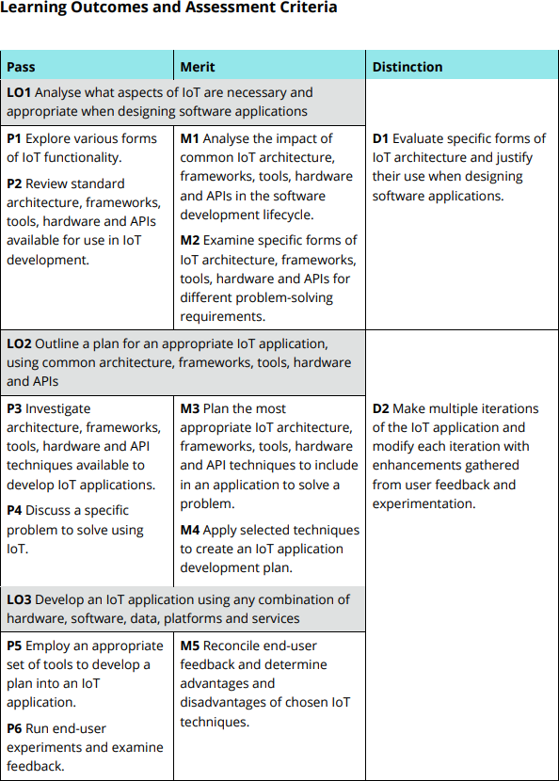

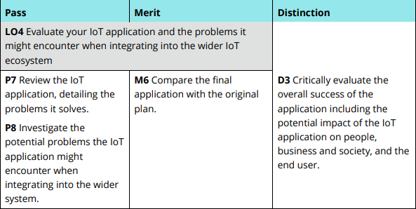

# Content

Assessor Feedback 2

* 2

Grade: 2

Assessor Signature: 2

Date: 2

Resubmission Feedback 2

*Please note resubmission feedback is focussed only on the resubmitted work 2

Grade: 2

Assessor Signature: 2

Date: 2

Internal Verifier’s Comments 2

Signature & Date: 2

# Plagiarism 6

Content 15

Acknowledgment 22

LO1: Examine whether IoT features are relevant and essential for software application creation 23

Overview of Internet of Things Applications 23

Main IoT Components 23

Typical Internet of Things Uses 23

Exploration of Different IoT Functionality 25

Automation of Smart Homes 25

Wearable Technology 25

Industrial IoT (IIoT). 25

Smart Cities 25

Farming 26

IoT Architecture Frameworks 26

Internet of Things Tools 26

Internet of Things Hardware 27

Internet of Things APIs 27

Summary 28

Common IoT AFTHA Techniques and Their Effect on the Software Development Life Cycle (SDLC) 28

Analysis and Specification of Requirements 28

System Architecture 28

Development 29

Testing and Quality Assurance 29

Deployment 29

Maintenance and Support 29

Security 29

Optimizing Performance and Scalability 30

Documentation and Training 30

Analysing Particular AFTHA Methods for Needs in Problem-Solving 30

Assessment and Argumentation of Particular Types of IoT Architecture for Software Programs 32

Three-Layer Architecture 32

Middleware-Based Architecture. 32

Service Oriented Architecture (SOA) 32

Fog Computing Architecture 33

Edge Computing Architecture 33

Examples of IoT Implementations in the Real World 33

LO:2 Create a blueprint for a suitable Internet of Things application utilizing standard hardware, tools, architecture frameworks, and APIs 35

Examining AFTHA's Use in the Development of IoT 35

AFTHA's advantages for IoT development 36

IoT Application Areas for AFTHA 36

Difficulties and Things to Keep in Mind 37

Summary 37

Talk about the Specific Issue That IoT Devices Will Help Solve 37

Remote Patient Monitoring and Healthcare 38

Automation of Smart Homes 38

Predictive maintenance and industrial automation 38

Environmental Monitoring 38

Agricultural Practices and Intelligent Farming 39

Logistics and Supply Chain 39

Consumer Experience and Retail 39

Intelligent Cities 39

Issue Identification: Honeywell Company Home Security System 40

Background Information 40

Definition of the Problem 40

IoT Solution Suggestion 40

The Internet of Things' advantages 41

Summary 41

Decide on the Best AFTHA to Address the Issue 42

Implementation of Specific Methods in the IoT Development Strategy 43

A detailed development plan including timelines and explanations 45

Project Start-Up 45

Activities 45

Timetable (First Month) 45

System Architecture 46

Activities 46

Timeline (two to three months) 46

Combination and Examination 47

Activities 47

Timeline (four to five months) 48

Implementation 48

Activities 48

Timeline (Six Month) 49

Maintenance and Optimization 49

Activity 49

Timeline (continuously after deployment) 50

Hardware Materials 50

Software Services 51

Additional Sources 51

Cost Plan Table 52

Hardware Cost Plan 52

Software Cost Plan 52

Human Resources Plan 52

Training Plan 53

Miscellaneous Plan 53

Total Project Cost 53

Dashboard with Node-RED flow screenshot 54

Smart Home Security System Using IoT 54

Hardware 54

The devices 54

Intelligent Alarms 54

cameras for security 54

Motion Detectors 55

Intelligent Locks 55

Infrastructure of Networks 56

Routers 56

Wi-Fi Range Extenders 56

Internet of Things Gateways 56

Software 57

Smartphone Applications 57

Platforms for Home Automation 57

Data 57

Sensor Information 58

Platforms 58

Platforms for IoT Clouds 58

AWS IoT 58

Microsoft Azure IoT Hub 58

Google Cloud IoT 58

Services 59

Services for Device Management 59

Services for Data Analytics 59

Protective Services 59

Automated Services 60

Visualization 60

Node-RED Integration of Flow Node-RED 60

Flow Example 60

Visualization 61

An Example of an API-Integrated Home Security Flow 61

Simulate Sensor Data 62

Process the Data 62

Send Data to Cloud API 63

Visualize the Data 63

Node-RED Flow Configuration Simulate Sensor Data 63

Process the Data 64

Send Data to Cloud API 64

Display the Data 64

LO3: Create an Internet of Things application with any mix of services, platforms, software, hardware, and data. 67

Illustration of the Selection of Useful Development Tools 67

Hardware Parts 67

Protocols for Communication 68

Platforms for Software Development 68

Web and Mobile Application Development 68

Privacy and Security 69

A sample IoT home security system development stack 69

The IoT-based home security system's parameters 70

Motion-detecting (Motion Sensors) 73

Putting the IoT Application in Place with Selected Frameworks and Tools 76

Mobile Application for Home Security Systems 77

IoT-based home security system feedback form and sample feedback 87

Analyzing and Assessing End-User Comments 102

Analyzing Responses 102

Operational 103

Achievement 103

Support 104

Extra Elements 104

Assessment of Comments 104

Iterative Creation of the Internet of Things Application Using User Input 105

Creating the Internet of Things App Iteratively 105

Initial Development Phase 105

Iteration 1: Improvement in Response to Input 106

Iteration 2: Performance Optimization and Advanced Features 106

Complete User Feedback Integration in the Final Iteration 106

Summary 106

Examining User Input and Talking About the Benefits and Drawbacks of the Techniques Employed 107

Analysis of User Feedback 107

Pros and Cons of the Applied Techniques 107

Suggestions for Development 107

Enhance Instructional Resources 107

Boost the Stability of the System 108

Enhance the Design of the User Interface 108

Improve Notification Mechanism 108

Increase the Capabilities of Real-Time Data 108

Summary 108

LO4: Assess the challenges your IoT application may face in connecting with the larger IoT ecosystem 109

Examining the Developed Internet of Things App 109

Issues Solved by the Internet of Things Application 109

Advantages of Internet of Things Use 110

Summary 111

Talking About Possible Integration Problems 111

Problems with Compatibility 111

Safety issues 112

Scalability Problems 113

Conclusion 113

Evaluating the Completed Application in Relation to the Original Project Plan 113

Overview of the Initial Project Plan 113

Overview of the Final Application 114

Disturbances from the Original Project Schedule 114

Knowledge Acquired 114

Conclusion 115

The critical assessment of the application's performance 115

Comparing the original project plan 115

Overview of the Final Application 115

Changes from the Original Plan 116

Analyzing User Input 116

Conclusion 117

References 118

**Acknowledgment**

I want to sincerely thank my friends, ESOFT Metro Campus, and my instructor, Mr. Nisal Thalpawila, for all of their assistance and guidance during my academic journey. My academic development has been greatly influenced by my lecturers' unwavering commitment to sharing their knowledge and their enthusiasm for what they teach. My friends have brought so much joy and memory to this journey with their unfailing support and companionship. I am also appreciative of my school for offering a supportive environment and the tools I need to succeed in my studies. I consider myself extremely fortunate to have had such amazing people and organizations in my corner, and I will always be appreciative of what they have done to further both my academic and personal growth.

# LO1: Examine whether IoT features are relevant and essential for software application creation.

**Overview of Internet of Things Applications.**

The Internet of Things, or IoT, is a network of devices that are connected to one another and use the internet to share data and communicate. These gadgets might be anything from simple domestic items to sophisticated industrial instruments. The main goal of the Internet of Things is to allow items to communicate, connect, and exchange data in order to boost productivity, improve user experiences, and open up new avenues for innovation. ([www.javatpoint.com,](http://www.javatpoint.com/) n.d.)

# Main IoT Components

Sensors and devices, connection, data processing, and user interfaces are among the essential elements of the Internet of Things. Devices and sensors gather information from the surroundings or from user input. Thanks to connectivity, this data can be transferred to other devices or the cloud via Bluetooth, Wi-Fi, and cellular networks, among other methods. Processing data is done locally or in the cloud in order to extract valuable insights. In conclusion, user interfaces facilitate communication with users via dashboards, mobile applications, or other interfaces. ([www.javatpoint.com,](http://www.javatpoint.com/) n.d.)

# Typical Internet of Things Uses

Among the most popular IoT applications are smart homes. Security systems, heating, cooling, and lighting may all be controlled remotely thanks to home automation systems. Smart appliances may be monitored and controlled with smartphones, which improves convenience and energy economy. Examples of these appliances are washing machines and refrigerators. ([www.javatpoint.com,](http://www.javatpoint.com/) n.d.)

Fitness trackers and smartwatches are the most popular wearables now on the market. Fitness trackers, such as Fitbits, track heart rate, sleep habits, and physical activity to give consumers important health information. Combining the features of a watch and a smartphone, smartwatches provide alerts, health monitoring, and other features. ([www.javatpoint.com,](http://www.javatpoint.com/) n.d.)

Significant breakthroughs in the healthcare sector are made possible via IoT. Healthcare professionals can ensure prompt actions by monitoring patients' vital signs in real-time through the use of remote monitoring devices. ([www.javatpoint.com,](http://www.javatpoint.com/) n.d.)

Dispensers with smart features make sure patients take their medications on schedule, which enhances compliance with treatment regimens. ([www.javatpoint.com,](http://www.javatpoint.com/) n.d.)

Applications of Industrial Internet of Things (IIoT) include asset tracking and predictive maintenance. Systems for predictive maintenance keep an eye on machinery to foresee and stop malfunctions, cutting down on downtime and repair expenses. Asset tracking makes it possible to trace an asset's location and status in real time, which enhances inventory control and logistics. ([www.javatpoint.com,](http://www.javatpoint.com/) n.d.)

IoT makes precise farming and animal monitoring possible in agriculture. Precision farming is the process of optimizing agricultural methods and raising yields by using Internet of Things (IoT) sensors to monitor crop health, weather, and soil moisture. Systems for tracking livestock's location and health allow for improved management and welfare of the animals. ([www.javatpoint.com,](http://www.javatpoint.com/) n.d.)

IoT is used by smart cities to improve urban living. Traffic management systems monitor and control traffic flow using cameras and sensors to lessen congestion and increase safety. By using smart bins that alert users when they need to empty, smart waste management systems optimize waste collection routes while cutting expenses. ([www.javatpoint.com,](http://www.javatpoint.com/) n.d.)

Advantages of Internet of Things

IoT has several advantages, such as better user experiences, cost reductions, efficiency gains, and safety and health improvements. Predictive maintenance and optimal resource utilization lower operating costs, while process automation and real-time data delivery enhance decision-making. Remote monitoring makes rapid interventions in healthcare possible, and personalized and convenient services improve user experiences. ([www.javatpoint.com,](http://www.javatpoint.com/) n.d.)

IoT challenges

IoT has advantages, but it also has drawbacks. protection is a major problem since it's essential to safeguard devices from cyberattacks and ensure data protection. The need for good communication across various devices and systems gives rise to interoperability difficulties. Data privacy has to be safeguarded, guaranteeing that user data is not mishandled. Scalability is a problem as well because handling a big number of devices and the data they produce might be difficult. ([www.javatpoint.com,](http://www.javatpoint.com/) n.d.)

The IoT's future

With the development of edge computing, 5G, and artificial intelligence (AI), the Internet of Things has a bright future ahead of it. It is anticipated that IoT will permeate daily life even more, resulting in smarter homes, cities, and businesses as well as a more interconnected global community. This ongoing evolution is expected to result in more advancements and improvements across a range of industries, improving living standards and spurring economic expansion. ([www.javatpoint.com,](http://www.javatpoint.com/) n.d.)

# Exploration of Different IoT Functionality Automation of Smart Homes

IoT devices are used in smart home automation to improve security, convenience, and energy efficiency in homes. Motion sensors, cameras, and smart locks are all part of home security systems that give homeowners real-time monitoring and alarms. Smart thermostats and air conditioning systems regulate the climate by automatically adjusting the temperature according to the preferences and presence of the user, thereby maximizing comfort and minimizing energy use. Smart light switches and bulbs enable customers to automate and manage their lights from a distance. The ability to remotely control and receive status updates from smart appliances, such refrigerators, washing machines, and ovens, further enhances the convenience of managing a house. (Peerbits, n.d.)

# Wearable Technology

Wearable technology makes use of the Internet of Things to monitor fitness and health, improve personal safety, and offer easy access to information. Fitness trackers assist consumers in maintaining a healthy lifestyle by tracking heart rate, physical activity, and sleep patterns. Health monitoring equipment, such as medical sensors and smartwatches, monitor vital signs, blood sugar levels, and medication compliance. This data is useful for treating medical disorders. Wearable GPS location trackers improve personal safety by letting users track their movements while running or hiking and sharing their whereabouts with trustworthy contacts. (Peerbits, n.d.)

# Industrial IoT (IIoT).

Industrial IoT (IIoT) integrates IoT devices to maximize productivity, minimize downtime, and optimize operations, revolutionizing manufacturing and industrial processes. In order to save downtime and maintenance costs, predictive maintenance systems employ sensors to monitor the health of the equipment and anticipate faults before they happen. IoT devices that track products in transit improve supply chain management by streamlining logistics and improving inventory control. Smart grids and Internet of Things (IoT) devices are used by energy management systems in industrial settings to monitor and optimize power usage, lowering operational costs and energy waste. (Peerbits, n.d.)

# Smart Cities

IoT technology is used by smart cities to optimize resource management, increase public safety, and improve urban living. Transportation efficiency is increased by traffic management systems, which employ cameras and sensors to monitor traffic flow, adjust signal timings, and lessen congestion. environmental observation IoT devices monitor noise levels, water quality, and air quality, giving data that can be used to improve the health of urban environments. Smart surveillance and emergency response systems improve public safety by enabling quicker and more efficient responses to emergencies, protecting citizens' safety and well-being. (Peerbits, n.d.)

# Farming

Precision farming, which leverages IoT technology in agriculture, improves agricultural operations by offering up-to-date information on crop health, soil moisture, and meteorological conditions. With the use of this data, farmers may maximize crop yields and minimize resource use through fertilization, irrigation, and insect management. Devices for tracking livestock location and health allow for improved management and care. By minimizing water waste and enhancing crop health, automated irrigation systems make farming more effective and sustainable. They do this by adjusting water usage depending on soil and meteorological data. (Peerbits, n.d.)

# IoT Architecture Frameworks

The Industrial Internet Consortium (IIC) established the Internet of Things Reference Architecture (IoT RA), which prioritizes security, scalability, and interoperability. It consists of several layers, including those for data accumulation, edge computing, connection, and data processing. Use cases in the fields of healthcare, smart cities, and industrial automation are especially well-suited for this paradigm. (Jena, 2020)

Fog computing is the focus of the OpenFog Reference Architecture, which was developed by the Open Fog Consortium. By dividing data, processing, storage, and applications between the data source and the cloud, this method boosts security, lowers latency, and increases dependability. Autonomous vehicles, smart manufacturing, and smart grids are some of the major use cases. (Jena, 2020)

The Cisco IoT World Forum (IoTWF) Reference paradigm is a seven-layer paradigm that covers physical devices and controllers, edge computing, networking, data collection, data abstraction, application, and processes and collaboration. It is extensively utilized in environmental monitoring, smart homes, and linked healthcare. (Jena, 2020)

# Internet of Things Tools

Node-RED is a visual programming tool that is flow-based and perfect for connecting

devices, APIs, and web services. It is based on Node.js, which provides a large selection of pre-built nodes for diverse protocols and services, and has browser-based flow modification. Workflow automation, IoT integration, and quick prototyping are examples of common use cases. (GeeksforGeeks, 2023)

An open-source software ecosystem called Eclipse IoT is devoted to offering IoT solutions. It comes with such tools as Eclipse Kura for IoT gateways, Eclipse Paho for MQTT, and Eclipse Mosquito as a MQTT broker. Device management, MQTT communication, and the building of IoT gateways are all supported by this ecosystem. (GeeksforGeeks, 2023)

# Internet of Things Hardware

Raspberry Pi is a compact, low-cost single-board computer that is widely utilized in Internet of Things applications. It has support for many operating systems, Ethernet, Wi-Fi, and Bluetooth networking, and GPIO pins for sensor interfacing. Prototyping, home automation, and instructional projects are among its frequent uses. ([www.tutorialspoint.com,](http://www.tutorialspoint.com/) n.d.)

The open-source electronics platform Arduino is built on user-friendly hardware and software. It has a large community with lots of resources, easy interface with sensors and actuators, and comprehensive library support. Arduino is perfect for DIY projects, prototyping, and embedded systems. ([www.tutorialspoint.com,](http://www.tutorialspoint.com/) n.d.)

The low-cost Wi-Fi microchips ESP8266/ESP32 have microprocessor and a full TCP/IP stack. They provide great performance, low power consumption, integrated Wi-Fi, and Bluetooth (ESP32). These microchips are utilized in home automation, IoT devices, and wireless sensor networks. ([www.tutorialspoint.com,](http://www.tutorialspoint.com/) n.d.)

# Internet of Things APIs

Scalable data intake, device administration, secure device connections, and connectivity with other Google Cloud services are all offered by Google Cloud IoT Core. It is extensively utilized in smart cities, predictive maintenance, and industrial IoT. ([www.hologram.io,](http://www.hologram.io/) n.d.)

Device administration, safe communication, data processing, analytics, and interaction with additional AWS services are all provided by AWS IoT. Asset tracking, connected cars, and smart agriculture are some of its application cases. ([www.hologram.io,](http://www.hologram.io/) n.d.)

Device administration, secure connectivity, cloud-to-device and device-to-cloud messaging, and Azure service integration are all made easier with Microsoft Azure IoT Hub. It is appropriate for energy management, smart buildings, and healthcare. ([www.hologram.io,](http://www.hologram.io/) n.d.)

ThingSpeak is an open-source Internet of Things platform that offers real-time data collection, display, and analysis along with MATLAB analytics. Applications for smart homes, agriculture, and environmental monitoring are among its frequent uses. ([www.hologram.io,](http://www.hologram.io/) n.d.)

# Summary

The Internet of Things ecosystem is large and ever-changing. The aforementioned hardware, frameworks, tools, and APIs offer a solid foundation for creating and implementing IoT solutions. The exact use case, project needs, and scalability all play a role in choosing the right components.

# Common IoT AFTHA Techniques and Their Effect on the Software Development Life Cycle (SDLC)

**Analysis and Specification of Requirements**

IoT AFTHA approaches are essential for determining the specific requirements of IoT systems during the requirements analysis and specification phase. These methods aid in defining requirements for scalability, security, connection, and interoperability in a clear and concise manner. Through early attention to IoT-specific requirements including device compatibility, data handling methods, and network communication standards, the development process may more effectively accommodate the heterogeneous and intricate character of IoT situations. (Anon, 2023)

# System Architecture

AFTHA approaches give developers of IoT systems an organized way to approach the system design phase. Robust architectures that smoothly connect cloud services, edge devices, sensor networks, and data analytics components are made possible by these frameworks. Developers may guarantee that the different IoT system components function together effectively and efficiently by adhering to AFTHA rules. This will result in an architecture that is more unified and functional as a whole. (Anon, 2023)

# Development

Using specified AFTHA patterns and best practices has a major positive impact on the development phase. These methods assist developers in building code that complies with Internet of Things industry standards, including data serialization formats (JSON, XML), communication protocols (MQTT, CoAP), and real-time data processing techniques. IoT applications of higher quality are produced when development processes are more effective and error-free due to adherence to these established norms. (Anon, 2023)

# Testing and Quality Assurance

Comprehensive testing methodologies are required by AFTHA techniques in order to guarantee the dependability and functionality of IoT systems. This comprises testing individual components as unit tests, testing related devices as integration tests, and testing the load, performance, and security of the entire system. To replicate IoT environments, specialized testing frameworks and tools are frequently used. This enables a full assessment and validation of the functioning and resilience of the system. (Anon, 2023)

# Deployment

AFTHA approaches facilitate device configuration and management across several sites throughout the deployment phase. These tactics make it possible to remotely control and automate the deployment of Internet of Things devices, which guarantees the effective rollout of updates and patches. Developers can minimize disturbance and downtime while preserving the operation and integrity of the Internet of Things system by utilizing AFTHA principles. (Anon, 2023)

# Maintenance and Support.

Continuous monitoring and predictive maintenance made possible by AFTHA techniques expedite the maintenance and support phase. Proactive maintenance is made possible by early detection of anomalies and possible breakdowns thanks to real-time monitoring technologies and analytics. AFTHA also stresses the significance of routine security patching and updates to protect the system from flaws and guarantee long-term dependability and security. (Anon, 2023)

# Security

IoT development must prioritize security, and AFTHA approaches offer a strong framework

for putting the required security safeguards in place. This include the application of data encryption, authentication techniques, secure communication protocols, and frequent security assessments. One of the biggest obstacles in the growth of IoT is ensuring data integrity and safeguarding the system from cyberattacks by adhering to AFTHA requirements. (Anon, 2023)

# Optimizing Performance and Scalability

IoT solutions that are high-performing and scalable can be designed with the help of AFTHA methodologies. Systems that can grow vertically by adding more processing power and horizontally by adding additional devices are developed according to these frameworks. To manage massive data volumes and guarantee low-latency connection, performance optimization techniques are integrated, enabling high performance to be maintained even as the system expands. (Anon, 2023)

# Documentation and Training

For IoT systems to be implemented and maintained successfully, proper documentation and training are crucial. The significance of producing thorough documentation that addresses architectural design, coding standards, deployment methods, and maintenance guidelines is emphasized by AFTHA methodologies. Additionally, training programs are essential because they give developers and operators the know-how to manage and run IoT systems successfully, assuring their continued success and adaptability. (Anon, 2023)

# Analysing Particular AFTHA Methods for Needs in Problem-Solving

Task decomposition is the process of dividing large, difficult jobs into smaller, more doable subtasks. By breaking down enormous tasks into smaller, more manageable pieces, this strategy is essential in several industries, including project management, where it helps create thorough project plans and timelines. Task decomposition makes it easier to manage code and guarantee that each module operates as intended in software development by facilitating the design and implementation of modular systems. By breaking down courses into modules or units, this method facilitates curriculum design in education by enabling targeted learning and simpler evaluation. (Deakin University, 2019)

Heuristic guidance offers general guidelines or methods based on experience to direct problem-solving. Heuristics speed up the diagnostic process by assisting medical professionals in making well-informed conclusions based on typical symptoms and previous situations. Heuristic guidance improves search algorithm performance by directing search towards more promising regions. Heuristics are another tool used by user interfaces to help users by recommending frequently used actions or shortcuts, which enhances productivity

and user experience overall. (Deakin University, 2019)

Modeling and simulation entail the use of models to forecast results and simulate various situations. In order to test designs under diverse circumstances without the need for actual prototypes, this technology is frequently utilized in engineering. It saves time and money. Simulations in economics are used to assess the possible effects of economic policies and forecast market trends. Modeling is a useful tool used by environmental scientists to design mitigation methods and forecast the effects of climate change, which offers important insights for resource management and policy decisions. In order to analyze massive data sets for patterns and insights and then visually represent the findings for simpler comprehension, data analytics and visualization are essential. Strategic planning is improved by the use of data analytics in business intelligence to guide decision-making based on metrics and patterns in data. Patient data tracking in healthcare facilitates the identification of health trends and enhances treatment strategies, ultimately improving patient outcomes. Experimental data is analyzed by researchers in a variety of domains to support theories and increase scientific understanding. (Deakin University, 2019)

Algorithms are used by machine learning and artificial intelligence (AI) to automate processes and enhance decision-making. Artificial intelligence (AI)-driven chatbots and virtual assistants in customer service offer round-the-clock assistance, enhancing client happiness and cutting expenses. Predictive analytics is used by the finance sector to manage risk and trade stocks, providing insights that help make lucrative decisions. Predictive maintenance and automated quality control help manufacturing by reducing downtime and guaranteeing effective production. (Deakin University, 2019)

With collaborative platforms, users may easily collaborate on common activities. Remote workers depend on tools like Slack, Trello, and Zoom because they make it easier for team members to collaborate regardless of where they are in the world. On websites like GitHub, where programmers work together to edit code and share their contributions with the community, open-source projects flourish. Online learning systems facilitate collaborative learning in the classroom by enabling students to exchange knowledge and work on projects together. Mechanisms for collecting user feedback are put in place to continuously improve procedures. Teams may swiftly and effectively iterate on their products in software development by utilizing feedback loops and continuous integration and deployment. (Deakin University, 2019)

Customer input helps product designers improve features and better satisfy user needs.

Real-time feedback systems improve curriculum and teaching strategies in the classroom by enabling teachers to modify their strategies in response to feedback and student performance. (Deakin University, 2019)

Context-Aware Systems are made to change how they behave according to the situation or surroundings. Context-aware systems are used in smart homes to customize the living experience by modifying device settings according to human preferences and behaviors.

Wearable technology offers context-aware health monitoring in the medical field, giving real-time information on a patient's state. Retailers provide individualized shopping experiences by using context-aware technologies to customize promotions and recommendations to specific customers based on their tastes and activity. AFTHA

approaches should be implemented with a few key concerns in mind. When approaches and tools are designed with the end-users' requirements and expectations in mind, they are guaranteed to be user-centric. Scalability is necessary to tackle challenges of varying sizes and complexity, enabling solutions to expand in response to demand. In order to preserve confidence and protect user data, security and privacy must be upheld. By guaranteeing compatibility with current technologies and systems, interoperability makes it easier to integrate and operate different platforms. AFTHA approaches can be effectively adjusted to meet particular problem-solving objectives in a variety of sectors by taking these considerations into account. (Deakin University, 2019)

# Assessment and Argumentation of Particular Types of IoT Architecture for Software Programs

**Three-Layer Architecture**

The Perception, Network, and Application layers make up the three-layer design. Data is gathered by the Perception Layer from sensors and devices, sent to the cloud or data center by the Network Layer, processed by the Application Layer, and made available to users.

Because of its simplicity, this architecture is simple to comprehend and put into practice. Due to its simplistic design, it can only support a limited amount of scalability and offers rudimentary security protections that can be improved with more layers or protocols. Small- to medium-sized Internet of Things applications with simple needs, including home automation or small-scale environmental monitoring systems, where the requirements for data flow and processing are not complicated, are a good fit for this architecture. (Jena, 2020)

# Middleware-Based Architecture.

The Device, Middleware, and Application layers make up a middleware-based architecture. The physical devices and sensors are part of the Device Layer; communication, data processing, and storage are managed by the Middleware Layer; and services are provided through the Application Layer, which communicates with end users. Because the middleware layer hides hardware details, this architecture is more flexible and scales more easily than the three-layer system. Middleware is appropriate for applications that need higher scalability and hardware abstraction since it can include strong security measures.

When integrating many device types and requiring an effective scalability, this architecture is perfect for industrial IoT applications or smart cities. (Jena, 2020)

# Service Oriented Architecture (SOA)

The Device, Service, and Application levels make up the Service-Oriented Architecture (SOA). Physical devices and sensors are part of the Device Layer; reusable services are

provided by the Service Layer and are available across a network; user-facing programs that utilize these services make up the Application Layer. Because services are loosely connected, SOA provides outstanding scalability, great modularity through reusable services, and the potential for high security through appropriate implementation of service interfaces and protocols. For large-scale, modular IoT applications, like healthcare IoT systems, where many services like patient monitoring, diagnostics, and data analytics must work together flawlessly, this architecture is perfect. (Jena, 2020)

# Fog Computing Architecture

The Fog, Cloud, and Device layers comprise the Fog computing architecture. Physical devices and sensors are part of the Device Layer, intermediate processing and storage are provided closer to the edge by the Fog Layer, and centralized processing and storage are offered by the Cloud Layer. This highly scalable design combines edge and cloud resources to reduce latency by processing data closer to the source. Additionally, by using dispersed data processing, security is improved. Applications where instantaneous data processing and low latency are essential, such driverless cars, real-time analytics in smart grids, and critical infrastructure monitoring, are well-suited for fog computing. (Jena, 2020)

# Edge Computing Architecture

The Edge and Device layers make up the architecture of edge computing. Physical devices and sensors are part of the Device Layer, whereas processing and storage at the network's edge are handled by the Edge Layer. By processing data at the edge, this design reduces latency, provides scalability based on the capabilities of the edge devices, and enhances security because data is processed locally. Applications that require instantaneous data processing, such real-time monitoring systems, industrial IoT, and wearable health devices, are ideally suited for edge computing because they prioritize speedy data processing and minimal latency. (Jena, 2020)

# Examples of IoT Implementations in the Real World Smart Homes

Among the most widely used Internet of Things applications are smart houses. Central hubs, such as the Amazon Echo and Google Home, allow users to control multiple areas of their home environment with voice commands. For example, over time, user preferences are learned by Nest and Ecobee smart thermostats, which then modify the temperature to maximize comfort and energy economy. These systems combine with other smart devices to create a smooth and practical home automation experience. Examples of these devices include lights, security systems, and appliances.

# Medical Care

IoT devices are transforming medical monitoring and patient care in the healthcare industry. Fitbits and Apple Watches are examples of wearable health monitors that track vital signs including heart rate, steps taken, and sleep patterns. This data is useful for both users and medical experts. IoT is used by remote patient monitoring systems to continuously track patients with chronic diseases, minimizing the need for hospital visits and enabling prompt medical interventions. Better health outcomes and more effective healthcare delivery are the results of these developments.

# Industrial Internet of Things (IIoT)

Manufacturing and industrial processes are being revolutionized by industrial IoT (IIoT). One important use is predictive maintenance, in which Internet of Things sensors track the condition of equipment in real time, anticipating possible problems before they arise and planning maintenance appropriately. This lowers maintenance expenses and downtime.

Furthermore, IoT is used by smart factories to optimize supply chain management, quality assurance, and manufacturing lines, all of which increase productivity and efficiency.

# Intelligent Cities

IoT technology is used by smart cities to improve municipal services and urban living. Road safety is increased and congestion is decreased with the help of intelligent traffic management systems, which track traffic flow and modify signal timings instantly. By adjusting brightness in response to activity levels and ambient light, smart street lighting systems drastically cut down on energy usage. These IoT applications contribute to the development of more sustainable, livable, and effective urban environments.

# Farming

Precision farming is a key component of how IoT is revolutionizing agriculture. Farmers can manage irrigation, fertilization, and pest control by using real-time data from IoT devices on crop health, weather, and soil moisture. Crop yields rise as a result, and resource waste declines. Furthermore, IoT sensors are used by livestock monitoring systems to track the whereabouts and health of animals, assisting farmers in better herd management and raising overall farm output.

# Shop

IoT is improving operational efficiency and consumer experience in the retail industry. IoT- enabled smart shelves know when inventory is low and immediately notify employees or place new orders. This guarantees the maintenance of inventory levels without the need for manual checks. Moreover, merchants may provide tailored incentives and recommendations by using IoT devices to track customer behavior and preferences, which increases customer happiness and loyalty.

# Logistics and Transportation

Logistics and transportation have greatly improved thanks to IoT technology. Fleet management systems optimize routes and save operating costs by using Internet of Things (IoT) to track vehicle whereabouts, fuel consumption, and driver behavior. IoT sensors are used in cold chain logistics to make sure that products that are sensitive to temperature, including food and medications, are stored and delivered in the best possible ways, preserving product quality and safety all the way through the supply chain.

# Energy Administration

Another important area that gains from IoT applications is energy management. Smart meters assist utility companies and consumers monitor consumption and cut waste by giving real-time data on energy usage. By enhancing efficiency, averting outages, and monitoring power distribution networks, IoT technologies also help with grid management. These developments help to create a more dependable and sustainable energy system.

# Environmental Observation

IoT-based environmental monitoring systems use a variety of environmental parameters to track and report on. Cities and people can take action to minimize pollution by using air quality monitoring systems, which measure pollutants and offer real-time data on air quality. In a similar vein, IoT is used by water quality monitoring systems to track parameters in lakes, rivers, and water delivery systems, guaranteeing environmental compliance and safety. By offering precise and fast information, these applications contribute to the preservation of the environment and public health.

# LO:2 Create a blueprint for a suitable Internet of Things application utilizing standard hardware, tools, architecture frameworks, and APIs.

**Examining AFTHA's Use in the Development of IoT**

Important AFTHA Features for IoT Development

Adaptive security features of AFTHA allow it to adapt to the ever-changing IoT environment's conditions and context. This is essential for managing a wide variety of dynamic IoT networks and devices. AFTHA keeps an eye on security protocols and makes necessary adjustments to keep IoT systems safe from new and emerging threats.

Because of its adaptable architecture, AFTHA can accommodate a large variety of devices and communication protocols. This adaptability is crucial for incorporating newly developed gadgets and technology. Developers can more readily upgrade and grow IoT systems with a flexible architecture without needing to do significant redesigns. (News- Medical.net, 2022)

Because IoT devices frequently need to communicate with one another on their own, trust is essential. In order to improve overall security and cooperation, AFTHA incorporates trust management procedures to guarantee that devices are able to assess and establish trustworthiness among themselves. By establishing dependable connections between devices, these trust mechanisms promote safe and effective communication. (News- Medical.net, 2022)

Because they consist of a variety of devices with varying capabilities and needs, IoT environments are by their very nature heterogeneous. By offering a scalable and interoperable framework that can handle a variety of devices and systems, AFTHA accommodates this heterogeneity. Complex IoT ecosystems require this support for heterogeneity in order to operate effectively. (News-Medical.net, 2022)

# AFTHA's advantages for IoT development

AFTHA dramatically improves IoT system security by combining trust-based and adaptive techniques, strengthening their resistance to intrusions and attacks. Enhanced security protocols guarantee the preservation of data and device integrity, safeguarding confidential information and vital activities. (Yoo, n.d.)

IoT systems can scale efficiently thanks to AFTHA's flexible and heterogeneous design, which can handle more devices and linked nodes without sacrificing security or performance. As IoT systems expand, scalability is essential to enable smooth expansion and integration. (Yoo, n.d.)

The architecture of AFTHA guarantees the smooth operation of diverse IoT systems and devices, promoting interoperability across several platforms and technologies. One important benefit is interoperability, which enables effective communication and collaboration across various devices in the IoT ecosystem. (Yoo, n.d.)

Because AFTHA allows devices to dynamically assess and respond to trust levels, more reliable interactions are ensured and trust management plays a role in the reliability of IoT systems. Maintaining accurate and continuous operations is dependent on reliable systems, especially in crucial applications. (Yoo, n.d.)

# IoT Application Areas for AFTHA

In order to ensure smooth operation and dependable performance, AFTHA can improve security and interoperability among various smart home devices, including sensors, cameras, and appliances. Better integration and security for networked devices translate into enhanced safety and user experience in smart homes. AFTHA can offer strong security and trust management for important industrial systems, such as automation, supply chain management, and manufacturing processes. The improved security and dependability provided by AFTHA contribute to the seamless and safe functioning of industrial IoT. (Internet Society, 2019)

The adaptive and trust-based methods of AFTHA are especially useful in the healthcare industry, where sensitive data and vital equipment need to be very secure and reliable. These characteristics of the IoT for healthcare guarantee patient data security and the dependable operation of medical equipment. By guaranteeing safe and dependable communication across diverse IoT devices and systems, AFTHA can enable a broad range of applications for smart city efforts, from traffic control to public safety. AFTHA makes it easier to integrate and coordinate various systems in smart cities, which improves safety and urban living. (Internet Society, 2019)

# Difficulties and Things to Keep in Mind

AFTHA implementation can be challenging; it calls for thorough planning and the fusion of security, trust, and flexibility elements. The implementation of AFTHA is difficult, so a planned strategy is needed to make sure all the details are taken care of and incorporated.

Performance overheads from adaptive and trust-based methods may need for effective design and optimization in order to preserve system performance. To make sure that the advantages of AFTHA do not come at the expense of system speed and efficiency, performance considerations are crucial. (Internet Society, 2019)

Although it is difficult, achieving standardization across many devices and protocols is necessary for AFTHA to be widely used in Internet of Things scenarios. In order to foster interoperability and guarantee that AFTHA can be successfully deployed in a variety of IoT ecosystems, standardization activities are essential. (Internet Society, 2019)

# Summary

AFTHA is a smart way to handle the challenges of IoT development, with major benefits in terms of security, adaptability, and confidence. Although it necessitates careful consideration of implementation issues and performance consequences, its application in diverse IoT domains can result in more secure, scalable, and interoperable systems. AFTHA may greatly improve the capabilities and dependability of IoT systems in a variety of sectors and applications by tackling these issues.

# Talk about the Specific Issue That IoT Devices Will Help Solve

**Remote Patient Monitoring and Healthcare**

Patients with chronic diseases have limited access to real-time health data, which is a key concern in the healthcare business. Vital indications including blood pressure, heart rate, and glucose levels can be tracked by Internet of Things (IoT) health devices, which can then send the data to healthcare providers for ongoing supervision. For example, wearable technology can notify medical professionals of possible health problems before they worsen, allowing for prompt interventions and better patient outcomes.

# Automation of Smart Homes

Security concerns and inefficient energy consumption are two major issues in homes. Smart lighting controls, security cameras, and thermostats are examples of Internet of Things (IoT) gadgets that provide a solution by enabling homeowners to remotely monitor and manage their spaces. As an example, energy-saving smart thermostats may learn user preferences and make automatic adjustments to the heating and cooling system. Furthermore, by enabling remote access and real-time monitoring, smart locks and cameras improve home security by guaranteeing that houses are secure even while their occupants are not there.

# Predictive maintenance and industrial automation

Unplanned equipment downtime and ineffective maintenance programs are issues that industries must deal with. This can be addressed by IoT sensors, which can lower maintenance costs and downtime by tracking the functioning of machines and anticipating breakdowns. For instance, vibration sensors on manufacturing machinery can identify anomalous patterns that point to possible malfunctions, enabling proactive rather than reactive maintenance.

# Environmental Monitoring

Using conventional methods to monitor environmental conditions and pollutant levels is frequently insufficient. IoT devices may continuously monitor the quality of the air, water, and other surrounding elements, giving important information for efforts to safeguard the environment. Air quality monitors in urban areas can provide up-to-date information on pollution levels, allowing public health officials to take preventative measures to lower dangerous emissions.

# Agricultural Practices and Intelligent Farming

Inefficient use of resources such as water and fertilizers is a common problem faced by farmers. By keeping an eye on crop health, weather, and soil moisture, IoT devices can offer a solution that maximizes resource usage. For example, soil moisture sensors can only activate irrigation systems when necessary, saving water and increasing crop yields. This results in improved resource management for agriculture and more environmentally friendly farming methods.

# Logistics and Supply Chain

A prevalent issue in logistics and supply chains is the absence of oversight and visibility across the entire process. Real-time tracking of commodities, environmental monitoring, and timely delivery are all made possible by IoT devices. For example, temperature sensors in cargo containers guarantee that perishable goods are carried under ideal circumstances, preventing rotting and loss, and GPS trackers on delivery trucks offer real-time location data.

# Consumer Experience and Retail

Retailers frequently struggle with difficulties related to inventory management and poor customer experience. IoT gadgets can improve the in-store experience and expedite inventory management procedures. Real-time inventory tracking on smart shelves allows for automatic restocking, averting shortages and overstock scenarios. Beacons can also make tailored offers to consumers in-store, improving their in-store experience and increasing revenue.

# Intelligent Cities

Problems with trash management, transportation congestion, and inefficient energy use are common in urban settings. By enhancing energy efficiency, controlling waste collection, and streamlining traffic, IoT technology can contribute to the development of smart cities. IoT-enabled waste bins, for instance, may alert collection services when they are full, improving collection routes and cutting operational costs. Smart traffic lights can also adjust to changing traffic conditions in real time to lessen congestion.

# Issue Identification: Honeywell Company Home Security System

**Background Information**

Honeywell is a well-known global company in the home automation and security industry, renowned for its state-of-the-art technology and manufacturing know-how. Even with their cutting-edge solutions, there are still issues and room for development with their home security systems.

# Definition of the Problem

Ineffective Management and Monitoring of Home Security

# Absence of Integration of Real-Time Data

Real-time data from multiple sensors and devices may not be seamlessly integrated into current home security systems. Delays in identifying and handling security breaches or emergencies may arise from this.

# complex user interfaces

Existing systems may have extremely complicated user interfaces that make it challenging for homeowners to efficiently adjust and personalize their security settings.

# Limited remote access and control.

Homeowners may be less able to monitor and control their security when away from home due to potential restrictions on remote access and management of security equipment.

# Inadequate predictive maintenance.

Current systems might not be able to anticipate and stop possible malfunctions or maintenance problems in an efficient manner, which would increase downtime and decrease reliability.

# IoT Solution Suggestion

Entire Home Security System Powered by IoT

# Network of Integrated Sensors

Install a network of linked Internet of Things (IoT) sensors, such as cameras, door/window sensors, and motion detectors, to supply real-time data to a central system.

# Friendly Mobile Application

Provide a user-friendly mobile application that enables homeowners to conveniently monitor, control, and alter their home security settings from any location.

# Improved Control and Access from a Distance

Allow homeowners to react instantly to security warnings by enabling remote access to security cameras, alarms, and other equipment via the mobile app.

# Alerts and Predictive Maintenance

Incorporate predictive maintenance algorithms that evaluate sensor data to anticipate possible system malfunctions and notify homeowners to carry out essential maintenance prior to problems developing.

# The Internet of Things' advantages

**Enhanced Safety and Security**

The integration of real-time data and remote access facilitates prompt identification and remediation of security breaches, hence augmenting the overall safety of homes.

# Improved User Experience

Homeowners can more easily and effectively monitor their security systems when they have an interface that is easy to use.

# Enhanced Trustworthiness

Predictive maintenance guarantees consistent, dependable performance of home security systems while minimizing system downtime.

# Increased Adaptability and Authority

The ability to monitor and control their home security from anywhere gives homeowners piece of mind when it comes to enhanced remote access and control.

# Summary

Through the implementation of an Internet of Things-enabled home security system, Honeywell may effectively enhance the efficacy, dependability, and user experience of its

home security products. In order to satisfy the changing expectations of contemporary homes, this solution makes use of IoT technology to offer complete security coverage, predictive maintenance, and remote management.

# Decide on the Best AFTHA to Address the Issue

Determine the Issue

Clearly defining and identifying the problem or difficulty is the first step towards solving it. This entails being aware of the problem's symptoms and underlying causes. Getting feedback from team members, users, or stakeholders who are involved in the problem or are impacted by it is crucial. You can make sure that any solution developed tackles the underlying issue and doesn't only treat the symptoms by having a clear understanding of the situation.

Assemble information

The next important step after identifying the issue is to compile all pertinent data associated with it. This entails gathering information, comments, and any records that can shed light on the character and extent of the issue. It's critical to tackle this step in a comprehensive manner, making sure you have a comprehensive understanding of the issue from all angles. The more comprehensively you gather information, the more prepared you'll be to create workable solutions that take into account every pertinent facet of the issue.

Come up with ideas for solutions

Through the creative process of brainstorming, you can come up with a number of possible solutions for the problem that has been recognized. Encourage team members or stakeholders to generate ideas and have candid conversations. During this phase, quantity is more important than quality because varied ideas might lead to creative solutions. In order to encourage a free flow of creativity, refrain from judging or criticizing ideas too soon. The objective is to investigate several methods, taking into account both traditional and non- traditional fixes that might be able to solve the issue successfully.

Evaluate Solutions.

The next stage is to assess each possible solution using predetermined standards after a list of them has been generated. Feasibility, efficiency in treating the underlying problem, cost, implementation time, and stakeholder impact are a few examples of these factors. To ascertain which solution has the best chance of actually solving the problem, it is crucial to evaluate each one impartially in light of these standards. Performing more study or analysis to obtain more information that aids in decision-making may be necessary during this phase.

Choose the best solution.

It's time to decide which solution is best after weighing all of your options. The solution that is selected should most likely solve the problem in an efficient manner and closely match your requirements. Make sure to weigh the advantages and disadvantages of each option before choosing one. Before moving forward, it could be beneficial to confer with pertinent parties or specialists to obtain more information or confirmation.

Plan Implementation

Once a solution has been chosen, provide a thorough plan outlining how it will be implemented. This plan ought to outline precise actions, due dates, necessary resources, and roles that should be given to persons or groups. Divide the implementation process into digestible pieces and set explicit goals so that you can monitor your progress. Prepare for probable difficulties or roadblocks that might appear during execution and create backup strategies to reduce hazards. Good planning creates the conditions for carrying out the selected solution in a seamless and successful manner.

Carry out the Plan

It's time to execute the implementation plan when it has been finalized. Make certain that everyone in the team or involved understands their duties and responsibilities. Keep a tight eye on the situation to make sure that everything is finished on time and that any problems or delays are dealt with right away. To keep the momentum going and overcome any unforeseen obstacles that may come up, effective collaboration and communication amongst team members are crucial during this phase.

Examine and Modify

After the answer has been put into practice, give it some thought to see how well it solved the initial issue. Analyze results in relation to predetermined success standards and get input from relevant parties to gauge stakeholder satisfaction. Examine any variations from the anticipated outcomes and determine the knowledge gained from the encounter. Optimize the efficacy of the solution by making any necessary adjustments to the implementation strategy. Sustainably solving problems and improving solutions throughout time require constant progress.

You can approach problem-solving utilizing the AFTHA technique methodically by adhering to these defined phases, which will guarantee a well-considered and efficient resolution that satisfies stakeholders' needs and produces the required results.

# Implementation of Specific Methods in the IoT Development Strategy

Rapid Development and Prototyping

Prototyping is essential to IoT development since it allows for the early validation of concepts and functions. Rapid iteration is made possible by methods like 3D printing for tangible prototypes and platforms like Arduino or Raspberry Pi for electronic prototypes. With the help of these tools, developers can test and improve hardware and software

interactions more quickly, resulting in an IoT device that satisfies functional requirements and user expectations.

Agile Development.

Iterative and adaptive, agile approaches like Scrum and Kanban are ideal for Internet of Things initiatives. Teams can regularly provide incremental updates by segmenting development into smaller, more manageable tasks called sprints. By encouraging adaptability in the face of shifting needs or technological advancements, this strategy makes sure that the Internet of Things solution develops successfully over time.

Designing for Security

Given the possible weaknesses of linked devices, security is crucial to the growth of the Internet of Things. It is crucial to use strategies like threat modeling, which identify and reduce possible hazards early in the design process. Secure coding techniques, frequent security audits, and the implementation of robust encryption mechanisms all contribute to protecting IoT devices and data from cyber threats.

Machine Learning and Data Analytics

Large volumes of data are produced by IoT devices, and these data can offer useful insights to both individuals and enterprises. Organizations can use methods like machine learning and data analytics to extract valuable patterns and forecasts from Internet of Things data.

Through the utilization of algorithms for anomaly detection, predictive maintenance, or behavior analysis, enterprises can enhance productivity, streamline workflows, and provide users with customized experiences.

Integration of Clouds

For managing IoT deployments, cloud platforms like AWS IoT, Azure IoT, or Google Cloud IoT provide scalable infrastructure and services. Large volumes of IoT data may be handled effectively thanks to methods like cloud-based data processing, analytics, and storage. By utilizing serverless computing and containerization, scalability may be further improved and operational overhead can be decreased, enabling IoT applications to grow seamlessly in response to demand.

Design of User Interface

The goal of user interface (UI) design in Internet of Things apps is to provide responsive and user-friendly interfaces that improve user experience. User interfaces (UIs) are made to adjust to different screen sizes and devices through techniques like using responsive design principles. To make sure UI designs are up to user standards and user expectations, usability testing and user feedback are integrated into development rounds. IoT solution adoption, user pleasure, and engagement are all increased by a well-designed user interface.

Standards and Interoperability

For smooth communication and functionality, different IoT devices and platforms must be compatible with one another. Methods like implementing standardized communication protocols (like MQTT and CoAP) make it easier for devices to communicate and exchange data efficiently. Ensuring compatibility and interoperability across heterogeneous IoT environments through adherence to IoT standards (such as IoTivity, OCF) allows devices from different manufacturers to operate together easily.

# A detailed development plan including timelines and explanations

**Project Start-Up**

During the project commencement phase, the project's foundation is laid. This involves determining stakeholders, putting together the project team, and specifying the goals, parameters, and deliverables of the project. The objectives, limitations, and presumptions of the project are outlined in a project charter.

# Activities

Kick-off meeting for the project

Describe the project to the group of people involved and the stakeholders, including roles and duties.

Identification of stakeholders

List every stakeholder who has an interest in the project.

Describe the goals and scope of the project. Clearly state the goals of the project.

Create a project charter.

Record the goals, objectives, stakeholders, and scope of the project.

Group task

Assign roles to team members after selection.

# Timetable (First Month)

|  |  |
| --- | --- |
| **Week No** | **works** |
| 01 | Identifying stakeholders and holding the project kick-off meeting. |

|  |  |
| --- | --- |
| 02 | Describe the project's goals, objectives, and scope |
| 03 | Create the project charter and secure authorization. |
| 04 | Assign duties to members of the project team. |

**System Architecture**

The requirements are turned into a comprehensive building plan for the system during the system design phase. This entails drafting intricate designs, high-level architecture, and prototypes for user testing. Prior to starting development, it is intended to make sure the design satisfies all requirements.

# Activities

Collecting requirements

Get specific requirements from the relevant parties.

elevated system architecture

Create the system's overall architecture.

In-depth system architecture

Make thorough design documents that specify the construction of every component.

creation of prototypes

Create a prototype to highlight important features and get input in advance.

User feedback meetings

To improve the design, get input from stakeholders and possible users.

# Timeline (two to three months)

|  |  |
| --- | --- |
| **Week** | **Work** |
| 05 | Work with stakeholders to gather requirements. |

|  |  |
| --- | --- |
| 06 | Create a high-level system architecture |
| 07 | Write thorough documentation for the system design. |
| 08 | Check and complete the design of the system. |
| 09 | Create a prototype and get user input. |
| 10 | Collect requirements and hold user feedback sessions. |
| 11 | Use input to improve the system's design. |
| 12 | Complete the detailed design and begin the development readiness process. |

**Combination and Examination**

Developing the system, integrating its various parts, and running numerous tests to make sure everything functions as it should are all part of this phase. The goal is to find problems early and fix them to guarantee a successful deployment.

# Activities

System creation

Start developing the system's components and coding.

Combination

Integrate several modules and make sure they function as a unit.

Testing units

Check the functionality of each component separately.

Testing of system integration Examine the merged parts.

Testing for user acceptance (UAT)

To make sure the system satisfies their needs, have end users test it.

Bug repairing

Determine the problem and fix it if it comes up during testing.

# Timeline (four to five months)

|  |  |
| --- | --- |
| **Week** | **Work** |
| 13 | Start system development in week thirteen. |
| 14 | Keep working on the system. |
| 15 | Begin integrating the various system parts. |
| 16 | Test each module's unit independently. |
| 17 | Test the system's integration. |
| 18 | Find and address bugs. |
| 19 | Conduct user acceptance testing (UAT) |
| 20 | Get UAT input and implement the required changes |

**Implementation**

The process of putting the system into production is known as deployment. It entails completing the last testing, creating the deployment strategy, and making sure the system is reliable in an operational setting. During this phase, post-deployment support is also planned.

# Activities

Creating a deployment plan

Make a thorough deployment strategy for the system.

last-minute system evaluation

To make sure the system is prepared for production, thoroughly test it.

Finalized deployment schedule

Decide on a schedule for the deployment's tasks.

System setup

Transfer the system to an operational setting.

Tests after implementation

Check that the system operates as intended in production.

Project termination

Finalize the paperwork, turn it over to the operations group, and assess the project's results.

# Timeline (Six Month)

|  |  |
| --- | --- |
| **Week** | **Work** |
| 21 | Create the deployment schedule |
| 22 | Complete the system's last testing. |
| 23 | Complete the deployment timetable. |
| 24 | Install the system in a live setting. |
| 25 | Perform post-deployment testing |
| 26 | Close down the project and give the operations staff the reins. |

**Maintenance and Optimization**

To guarantee that the system is effective and functional after it is launched, it needs constant maintenance and optimization. During this phase, the system is being monitored, problems are being fixed, updates are being implemented, and performance is being optimized based on user feedback and performance measurements.

# Activity

System observation

Keep an eye on system utilization and performance at all times.

Resolution of issues

Find and address any flaws or problems that crop up after deployment. Recurring updates

Apply software upgrades and security fixes.

Enhancement of performance

Evaluate system performance and implement changes to improve user experience and efficiency.

Customer assistance

Assist users continuously and attend to their issues.

Gathering of feedback

Get user input to guide future upgrades and enhancements.

# Timeline (continuously after deployment)

From the seventh month onward: Consistently planned upkeep tasks including tracking, fixing bugs, and upgrades. To make sure the system functions well and satisfies user needs, ongoing efforts are made to optimize performance and provide user support.

**Hardware Materials**

|  |  |  |
| --- | --- | --- |
| **Item** | **Goal** | **Example** |
| RFID Readers and Tags | used in the home to track and identify individuals and items. | Valuable things can be equipped with RFID tags, and entrance points can be equipped with readers to track movements. |
| Smart Shelves with IoT Sensors | utilized for stock level monitoring, including determining whether a window or door is open or closed. | Windows and doors with smart sensors to identify unwanted entry. |
| Raspberry Pi (edge devices) | used to cut down on latency and dependency on cloud services for local data processing and decision- making. | Sensor data can be processed by a Raspberry Pi to initiate local notifications or alarms. |
| Automatic Guided Vehicles, or AGVs | Although it's not commonly utilized for home security, automated surveillance robots can benefit from it. | While patrolling the home, an AGV can send out alerts and a live video stream. |

|  |  |  |
| --- | --- | --- |
| RTLS Indicators | used to track a person's whereabouts in real time within their home. | Real-time location updates are provided by RTLS sensors, which are capable of tracking both people and things as they move. |

**Software Services**

|  |  |  |
| --- | --- | --- |
| **Item** | **Goal** | **Example** |
| Node-RED | for the creation of IoT applications based on flow. | establishing automated flows, such as setting off an alarm in the event that an illegal entry is discovered. |
| System IO | for the creation of firmware. | creating firmware to enable efficient communication between edge devices and  sensors and the main system. |
| Board of Things | for gathering and visualizing data. | putting warnings and sensor data on a dashboard that is  easy to utilize. |
| Azure IoT Hub / Amazon IoT Core | for data processing and storage via the cloud. | preserving past data and  using analytics to find trends and abnormalities |
| WMS Programs | For overseeing warehouse operations (suitable for inventory management of security devices but not immediately related to  residential security). | Organizing and monitoring the different home security systems. |

**Additional Sources**

|  |  |  |
| --- | --- | --- |
| **Item** | **Goal** | **Examples** |
| Instructional Resources | To instruct employees on how to use and maintain a home security system. | include homeowner training seminars, online tutorials, and user manuals. |
| Tools for Project Management | Planning, monitoring, and  reporting on the project's progress | Managing tasks, deadlines,  and deliverables with Jira or Trello. |

|  |  |  |
| --- | --- | --- |
|  |  |  |

**Cost Plan Table**

**Hardware Cost Plan**

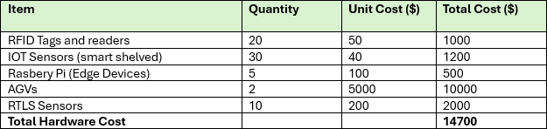

**Software Cost Plan**

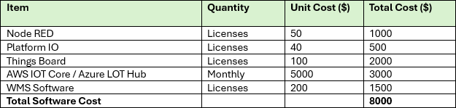

**Human Resources Plan**

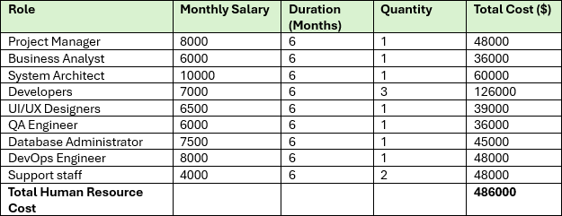

**Training Plan**

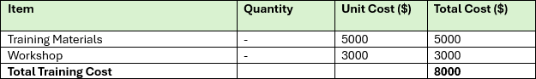

**Miscellaneous Plan**

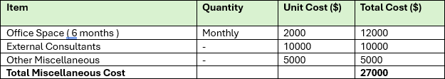

**Total Project Cost**

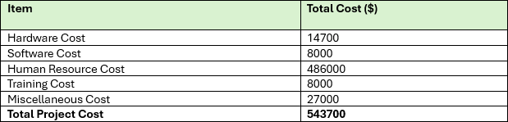

**Dashboard with Node-RED flow screenshot** **Smart Home Security System Using IoT**

**Hardware**

**The devices**

**Intelligent Alarms**

Categories:

Strobe lights, sirens, and quiet alerts. Qualities:

Combination:

connects to additional security equipment to sound an alert. Remote Control: Use a mobile app to arm and disable.

Alerts:

notifies the homeowner via phone.

# cameras for security

Categories:

Doorbell cameras, PTZ (Pan, Tilt, Zoom), outdoor, and inside cameras. Qualities:

Night Vision:

To record video in low light, use infrared or thermal imaging. Motion Detection: When motion is detected, an alert or recording is triggered.

Dual-Line Audio:

enables mobile app-based communication between an individual and the camera. Resolution: For high-definition video, this varies from 720p to 4K.

Storage:

Options for cloud or local storage (SD card).

# Motion Detectors

Sensor types include dual-technology, microwave, ultrasonic, and passive infrared (PIR). Features:

Scope:

depends on the type of sensor; usually, 10–30 feet. Adjustable sensitivity helps cut down on false alarms.

Strength:

cable- or battery-operated.

# Intelligent Locks

Categories:

Fingerprint, Bluetooth, Wi-Fi and keypad enabled. Qualities:

Remote Entry:

Open and close doors with a mobile app. Alerts: Reports of tampering and lock/unlock events.

Auto-Lock:

the door locks itself after a predetermined amount of time.

Combination:

integrates for automation with other smart home appliances.

# Infrastructure of Networks Routers

Functionality:

Controls connected devices, offers Wi-Fi, and routes internet traffic.

Dual-band/tri-band features:

provides two frequencies (2.4 GHz and 5 GHz) for optimal performance.

Safety:

VPN support, firewalling, and WPA3 encryption.

QoS:

Setting up Quality of Service to give security device traffic priority.

# Wi-Fi Range Extenders

Functionality: Increases Wi-Fi signal strength to cover home's dead spots. Qualities:

Compatibility: Compatible with the majority of mesh and router setups. Installation and settings are straightforward.

Performance: Allows several devices to connect to high-speed internet.

# Internet of Things Gateways

Functionality:

Processes data locally and links Internet of Things devices to the cloud.

Qualities:

Multiple IoT communication protocols, including Z-Wave, MQTT, and Zigbee, are supported.

Edge computing:

To cut down on latency, data is processed locally.

Security:

Makes certain that data is transmitted securely between devices and the cloud.

# Software

**Smartphone Applications**

Functionality:

All security devices are monitored and controlled centrally. Qualities:

Alerts in real time:

prompt notifications of any security incidents.

Watch live feeds from security cameras via live streaming. Remote control:

lock/unlock doors, arm/disarm alarms, and change settings.

# Platforms for Home Automation

Alexa from Amazon and Google Home Voice Control:

To operate security equipment, speak commands into your phone.

Establish automated procedures, such as turning on the lights when motion is detected. Integration:

Compatible with many different smart home products and services.

# Data

**Sensor Information**

Security equipment, such as cameras, motion sensors, and locks, collects data. Processing:

Patterns and abnormalities were examined.

Storage:

For later analysis, data may be kept locally on devices or on the cloud.

# Platforms

**Platforms for IoT Clouds** **AWS IoT**

Features include secure communication, data analytics, and device management.

Services:

AWS IoT Device Management, AWS IoT Analytics, and AWS IoT Core.

# Microsoft Azure IoT Hub

Features include device administration, bi-directional communication, and interaction with Azure services.

Services:

Azure Digital Twins, Azure Sphere, and Azure IoT Central.

# Google Cloud IoT

Features include data intake, real-time analytics, and secure device connections.

Services:

Big Query, Cloud Functions, Cloud IoT Core.

# Services

**Services for Device Management**

Functionality:

Oversee the lifecycle of a device from installation to retirement.

Qualities:

Push firmware upgrades to devices via remote updates. Diagnostics: Track the functionality and health of the gadget. Troubleshooting: Locate and fix problems from a distance.

# Services for Data Analytics

Functionality:

Evaluate information to enhance security and offer insights.

Qualities:

Finding anomalies: Recognize odd behaviors or trends. Use predictive analytics to anticipate any security lapses.

Reporting: Write up reports on trends and occurrences in security.

# Protective Services

Functionality:

Guard data and devices against online dangers.

Qualities:

Protect data both at rest and in transit with encryption.

Authentication: Make sure that the system is only accessible to authorized users and devices.

Danger Detection: Keep an eye out for and react to possible online dangers.

# Automated Services

Functionality:

Automatic reactions to specific circumstances. Qualities:

Rules Engine: Establish guidelines for automated processes, such as sounding an alert when motion is detected.

Integration: Enables smooth automation by integrating with other smart home appliances. Customization: Adapt automation rules to meet particular requirements.

# Visualization

**Node-RED Integration of Flow Node-RED**

Overview: A visual programming tool for Internet of Things applications that is flow-based. Nodes: Prefabricated parts for a range of uses (input, processing, output).

# Flow Example

Node of Input: Data is sent to Node-RED by the motion sensor. Processing Node: Examines data to look for trends in movement. The decision node assesses if a movement is exceptional.

Data is sent to a cloud platform (such as AWS IoT) by the output node.

Action Node: Based on analysis, this node sets off alarms or notifications. Cloud platform integration:

AWS IoT: Data can be sent to AWS IoT Core via MQTT nodes.

Microsoft Azure IoT Hub: To communicate with Azure IoT Hub, use MQTT or HTTP nodes.

Send data to Google Cloud IoT Core using HTTP nodes, according to Google Cloud IoT.

# Visualization

Node-RED Integration of Flow Node-RED

Overview: A visual programming tool for Internet of Things applications that is flow-based. Nodes: Prefabricated parts for a range of uses (input, processing, output).

# Flow Example

Node of Input: Data is sent to Node-RED by the motion sensor. Processing Node: Examines data to look for trends in movement. The decision node assesses if a movement is exceptional.

Data is sent to a cloud platform (such as AWS IoT) by the output node. Action Node: Based on analysis, this node sets off alarms or notifications.

Cloud platform integration:

AWS IoT: Data can be sent to AWS IoT Core via MQTT nodes.

Microsoft Azure IoT Hub: To communicate with Azure IoT Hub, use MQTT or HTTP nodes.

Send data to Google Cloud IoT Core using HTTP nodes, according to Google Cloud IoT.

# An Example of an API-Integrated Home Security Flow

**Simulate Sensor Data**

json

Copy code

{

Use an Inject Node to simulate sensor data from a motion sensor. JSON Object:

"device": "motion_sensor ",

"motion_detecte d": true,

"timestamp": "2024-07-16T12:00:00Z"

}

# Process the Data

Connect the Inject Node to a Function Node.

Configure the Function Node to process the motion detection data.

Javascript Copy code var motion

=msg.payload.motion_detected; var timestamp = msg.payload.timestamp;

if (motion) {

msg.payload = { "action": "Trigger Alarm", "timestamp": timestamp };

} else {

msg.payload = { "action": "No Motion Detected", "timestamp": timestamp };

}

return msg;

# Send Data to Cloud API

Add an HTTP Request Node to simulate sending data to a cloud platform. Connect the Function Node to the HTTP Request Node.

Configuration:

**Method**: POST

**URL**: https://example.com/api/home-security (Mock API endpoint)

# Visualize the Data

Connect the Function Node to a Debug Node to monitor the output.

# Node-RED Flow Configuration Simulate Sensor Data

Drag an Inject Node onto the canvas. Configure it to send a JSON object representing motion sensor data.

json

Copy code

{

"device": "motion_sensor ",

"motion_detecte d": true,

"timestamp": "2024-07-16T12:00:00Z"

}

# Process the Data

Connect the Inject Node to a Function Node.

Configure the Function Node with the provided function code to process the motion detection data.

# Send Data to Cloud API

Add an HTTP Request Node and connect it to the Function Node. Configure the HTTP Request Node with the following:

**Method**: POST

**URL**: https://example.com/api/home-security (Mock API endpoint)

# Display the Data

To see the output, connect the Function Node to a Debug Node.

This configuration offers a thorough walkthrough of how to use Node-RED for data processing, modeling, cloud integration, and visualization in the implementation of an Internet of Things-based home security system.

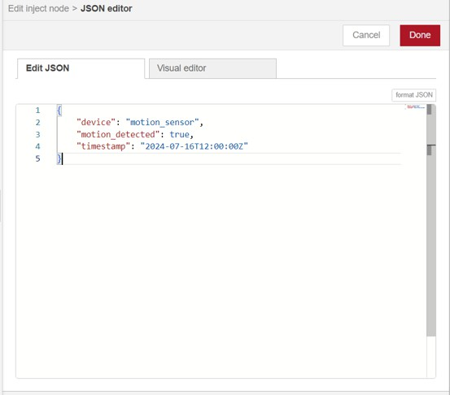

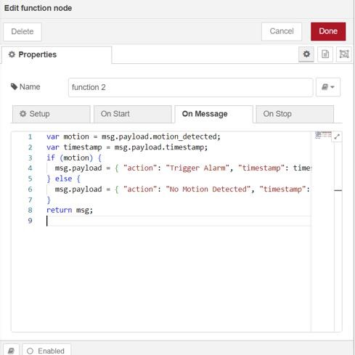

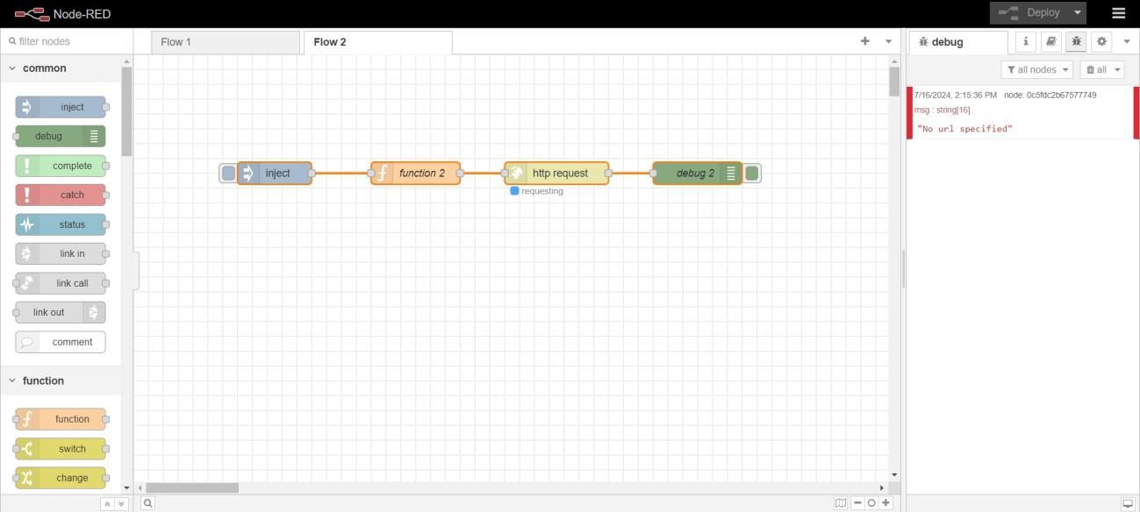

Link for Node-RED dashboard – <https://drive.google.com/drive/u/0/folders/1q6G8NveKTrQ7HFOS9Qm7Mdb2nWtcS5Ka>

**LO3: Create an Internet of Things application with any mix of services, platforms, software, hardware, and data.**

**Illustration of the Selection of Useful Development Tools**

**Hardware Parts**

Selecting the appropriate hardware is essential when building an Internet of Things (IoT) home security system.

Fundamental devices are microcontrollers and single-board computers, such as the Arduino and Raspberry Pi. Because of its well-known simplicity and ease of use, Arduino is a great choice for novices and straightforward tasks like reading sensor data and operating actuators. It has a large number of tutorials, libraries, and community assistance. For more complicated applications, nevertheless, its constrained memory and processing capability may be a disadvantage. However, the Raspberry Pi has more processing power and memory and runs a full operating system, often Raspbian. This makes it appropriate, while more hard to set up and configure, for performing more demanding activities like processing video, connecting to the internet, and hosting a web server.

The ability to detect a wide range of circumstances and occurrences requires sensors. PIR sensors are inexpensive, easy to use, and detect motion. As such, they are a great fit for integration with Arduino and Raspberry Pi. In order to detect openings and closings—which are essential for intrusion detection—door and window sensors employ magnetic systems.

Modern home security systems must include visual monitoring, which cameras give, but they also come with a higher processing power and bandwidth requirement. The monitoring of ambient conditions by additional sensors, such as temperature and humidity sensors, can assist in identifying anomalous changes that may point to a security breach. Security system actuators, like lights and alarms, are important components. Alarms are easy to interface with microcontrollers and offer an audible alert in the event of a security breach. Lights provide an additional degree of security by warding off intruders, signaling alarms, and being remotely controlled.

# Protocols for Communication

The effectiveness and dependability of the Internet of Things home security system depends on the communication protocol selected.

Because Wi-Fi is widely available, has a high bandwidth, and is simple to set up and use for streaming video and receiving real-time notifications, it is a popular option. It needs an established Wi-Fi network, though, and uses more power. By passing data through intermediary devices, Zigbee's mesh networking features and low power consumption enable devices to connect across larger distances. This makes it perfect for devices that run on batteries, even though it needs a Zigbee hub and has a lesser bandwidth.

Although Bluetooth is low power and works well for short-range communication, its restricted bandwidth and range make it less appropriate for large-scale home security systems. Like Zigbee, Z-Wave is primarily intended for home automation and offers mesh networking and low power consumption, but it also needs a Z-Wave hub and is not as popular as Bluetooth or Wi-Fi.

# Platforms for Software Development

The functionality and ease of development of the Internet of Things system are significantly impacted by the platforms used for software development.

The Arduino IDE is a straightforward, user-friendly environment for embedded systems programming that supports C/C++ programming and has a wide range of library support, which makes it perfect for programming Arduino boards. Because Python has many libraries for a wide range of tasks, including image processing with OpenCV, it is a powerful and simple language to learn that is frequently used with Raspberry Pi. Low-level Arduino and Raspberry Pi programming is typically done in C/C++ for more important and performance-sensitive tasks. IoT platforms that provide extensive tools and services for developing scalable and dependable IoT solutions include AWS IoT, Google Cloud IoT, and Microsoft Azure IoT. The scalability and dependability of AWS IoT are well recognized, and it integrates easily with other AWS services like Lambda and DynamoDB for device administration, data gathering, and analysis. Strong interaction with Google Cloud services and a comprehensive toolkit for IoT development are offered by Google Cloud IoT. Microsoft Azure IoT integrates seamlessly with the larger Azure ecosystem and provides a wide range of tools and services specifically designed for IoT solutions.

# Web and Mobile Application Development

IoT home security system mobile app development can be greatly aided by cross-platform frameworks such as Flutter and React Native. With the help of Flutter's extensive collection

of pre-designed widgets and the Dart programming language, developers can produce high- caliber, native apps for iOS and Android using a single codebase. JavaScript framework React Native facilitates code reuse between iOS and Android and has an extensive ecosystem of modules and tools in addition to strong community support.

Fundamental web development tools like HTML, CSS, and JavaScript are necessary to construct the web application's front end. A framework called Bootstrap makes responsive web design easier by offering pre-made elements and layout templates that expedite development and guarantee a unified look and feel. Node.js is a potent option for server- side development, allowing programmers to create scalable network apps with real-time data handling and communication capabilities—essential for a successful home security system.

# Privacy and Security

An Internet of Things-based home security system must prioritize security and privacy. Data communicated over the internet is secure thanks to encryption. Sensitive data must be protected during transmission using TLS/SSL protocols, and data saved on devices should be encrypted using AES, a popular symmetric encryption method. OAuth is a strong open standard for access delegation in the authentication space that offers safe user authentication and is frequently used to provide restricted access to user accounts to third-party applications. JWTs, or JSON Web Tokens, are small, safe tokens that can be used to send data securely between parties. They are frequently used in contemporary web applications for authorization and authentication.

# A sample IoT home security system development stack

Because of its processing power and capacity to run an entire operating system, a Raspberry Pi might be the primary microcontroller in a workable development stack for an Internet of Things home security system. PIR sensors for motion detection, door/window sensors for intrusion detection, and cameras for video monitoring can all be connected to this. Alerts would be audible and visible thanks to actuators like smart lights and alarm clocks. The communication protocol of choice would be Wi-Fi due of its high bandwidth and simplicity of integration with pre-existing home networks.

Python would be utilized for embedded programming on the Raspberry Pi, taking advantage of its robust libraries, in terms of software. Because of its scalability and dependability, AWS IoT would be the platform of choice for cloud connectivity and device management. React Native would be used to create a cross-platform mobile application that runs on both iOS and Android. To enable real-time data handling and communication, the web application would be constructed with Node.js for the back end and HTML, CSS, JavaScript, and Bootstrap for the front end. OAuth and JWT would handle secure user authentication and authorization, while TLS/SSL and AES would safeguard data transport and storage. This stack offers a balanced approach by carefully choosing each component

and technology, utilizing each one's characteristics to construct an all-encompassing, reliable, and scalable IoT-based home security system.

# The IoT-based home security system's parameters

**Control systems**

Within an Internet of Things (IoT)-based home security system, control systems coordinate the integration and functioning of multiple components. The command center is a central hub that facilitates communication between cameras, sensors, and user interfaces. With the use of smartphones or tablets, homeowners can now remotely control and monitor their house and access security alerts, live video feeds, and system settings in real time thanks to mobile applications. Web interfaces allow for even more flexibility by allowing normal web browsers to access the security system, making it easier to administer and customize security setups from any internet-connected device.

# Control of Power

Power management techniques are necessary to keep an Internet of Things (IoT)-based home security system reliable and operating continuously. Battery backup systems maintain vital communication and surveillance capabilities during blackouts by guaranteeing continuous operation. By providing outdoor equipment with sustainable energy sources and decreasing dependency on conventional power networks, solar power integration improves system resilience under a range of environmental circumstances.

# Interaction

An Internet of Things (IoT)-based home security system's communication architecture provides smooth connectivity and data transfer between devices. Strong communication between the home network's central hub and its networked sensors, cameras, and control interfaces is made possible via Wi-Fi connectivity. Short-range communication between compatible devices is supported by Bluetooth technology, enabling localized interactions and data transmission. For Internet of Things (IoT) devices, Zigbee and Z-Wave protocols offer low-power, mesh networking features that maximize energy efficiency and expand network coverage. In the event of Wi-Fi disruptions or failures, cellular connectivity acts as a dependable backup communication channel to maintain system performance.

# Alerts and Automation

An IoT-based home security system's proactive threat detection and response capabilities are enhanced by automation and alerting systems. When security events or user-defined scenarios are identified, automated reactions initiate specified actions, including turning on lights or locking doors. Real-time alerts allow for timely intervention and threat reduction by notifying homeowners via email or mobile notifications when crises or suspicious

activity is discovered. Integrating with emergency services improves homes' overall safety and security measures by ensuring quick reaction coordination in dire circumstances.

# Senses/Sensors

An IoT-based home security system's sensors are essential because they can identify possible threats and a variety of environmental changes. Motion sensors are utilised to identify movement within specific zones, thereby initiating notifications or alarms. Door and window sensors keep an eye on when entry points open and close, giving information about potential illegal entry. Glass break sensors quickly notify homeowners of possible invasions because they are sensitive to the sound frequencies connected to broken glass. Furthermore, smoke and fire sensors are necessary for early fire hazard identification, quick response times, and the protection of people and property from fire-related disasters. Carbon monoxide sensors monitor potentially fatal gas levels and provide alarms to reduce health concerns, adding even more safety to the system.

# User Verification

An IoT-based home security infrastructure's security protections are strengthened by user authentication techniques, which protect crucial system data and functionality. By authenticating user identities, password protection protocols limit unauthorized access to security

# Usability

When creating an intuitive and user-friendly interface for an Internet of Things-based home security system, usability is crucial. A well-thought-out user interface guarantees accessibility and convenience of use, giving homeowners easy-to-use controls and thorough visibility into the workings of their security system. By providing hands-free monitoring of security settings and surveillance activities, voice control integration with well-known virtual assistants like Alexa or Google Assistant improves user engagement and convenience within the smart home ecosystem.

# Cameras

Cameras are essential surveillance instruments in an Internet of Things home security system. Indoor cameras are placed in strategic locations throughout the house to keep an eye on important areas. They provide real-time video feeds that may be viewed remotely using web interfaces or mobile apps. By extending monitoring capabilities to the outside of the property, outside cameras help prevent intrusions and offer visual proof in the event that security is compromised. By enabling homeowners to view and communicate with guests at the front door, doorbell cameras enhance overall security and provide them more control over access points while also adding convenience.

# Managing data

In an IoT-based home security ecosystem, data management techniques are essential for protecting sensitive data and maximizing operational effectiveness. Cloud storage solutions

offer expandable storage capacity and quick access from various devices by securely storing video footage, sensor data, and system logs in distant servers. On-site data retention is provided by local storage solutions for improved privacy and adherence to data protection laws. By encrypting data transmission and storage, encryption technologies provide end-to- end security by reducing the danger of cyberattacks or unwanted access.

# Settings and Controls for the system.

By requiring extra verification procedures, such SMS codes or biometric identifiers, to confirm user credentials, two-factor authentication improves security. Access controls are further strengthened by the robust identity verification methods provided by biometric authentication technology, such as facial recognition and fingerprint scanning.

# Environmental Observation/Monitoring

An Internet of Things (IoT)-based home security system's environmental monitoring features go beyond standard security measures to include environmental safety and awareness. Temperature and humidity sensors keep an eye on the conditions within homes and warn homeowners of any dangers like overheating or problems with humidity. By early detection and timely alerts, water leak sensors mitigate property damage and lower the danger of flooding accidents by detecting the existence of water accumulation or leaks.

# Reliability and Maintenance

An IoT-based home security system's long-term performance and operational integrity depend on its maintenance and reliability procedures. Frequent firmware and software upgrades improve system operation and security by patching holes and adding new features to meet changing user demands and growing threat scenarios. Self-diagnostic features allow the system to detect and report malfunctions or performance problems before they become serious ones. This helps with prompt maintenance and troubleshooting to reduce downtime and guarantee homeowners' continuing security and peace of mind.

# Combination with Additional Smart Home Appliances

An IoT-based home security setup's usefulness and interoperability are enhanced by integration with other smart home devices, which promotes a coherent smart home ecosystem. Security systems and smart locks work together seamlessly to provide remote control, activity log monitoring, and access permission monitoring for doors. By using scheduled lighting schedules to simulate occupancy, smart lights improve security measures by discouraging prospective attackers and encouraging energy conservation. By modifying temperature settings in response to occupancy patterns and environmental factors, smart thermostats maximize energy efficiency and home comfort while also improving the overall functioning and user experience of an integrated smart home environment.

# Motion-detecting (Motion Sensors)

Motion sensors are essential to my IoT-based home security system's ability to identify illicit movements and send out notifications. When choosing motion sensors for this system, keep the following important factors in mind.

# Reaction Time

The speed at which a motion sensor picks up movement and notifies the central system is known as response time. In security settings, quicker reaction times are essential to guarantee prompt notice and action. Delays in detection might undermine security by giving possible trespassers additional time to enter the property. Superior sensors are engineered to reduce reaction times, deliver in-the-moment notifications, and augment the overall efficacy of the home security setup.

# Motion Detection Type

There are several different kinds of motion sensors, such as Dual Technology, Microwave, and Passive Infrared (PIR) sensors. PIR sensors are useful for detecting the presence of people since they can identify infrared radiation released by warm objects. Microwave sensors assess the reflection of microwave pulses they emit off of moving objects and can reliably detect things through walls. By requiring both technologies to trigger concurrently, dual technology sensors reduce false alarms by combining PIR and microwave approaches. It is easier to choose the appropriate sensor for a given situation when one is aware of the advantages and disadvantages of each type.

# Integration Proficiency

The term "integration capability" describes the sensor's capacity to function flawlessly with other platforms and smart home appliances. An ecosystem for complete home protection can be established by integrating a motion sensor with security cameras, lighting controls, and other Internet of things devices. Automated reactions, such turning on lights or taking a video when motion is detected, are made possible by this connection. Adding support for well-known smart home systems such as Google Home, Apple HomeKit, or Alexa improves the usefulness and usability of the sensor.

# Diminished False Alarm

In motion detection, false alarms can be a serious problem that cause unneeded anxiety and erode user confidence in the system. Pets wandering around the house might set off false alarms, which is why features like pet immunity are included. Users can change the sensitivity settings of sensors to minimize false positives caused by little motions, such as swaying curtains or passing cars. By demanding that several conditions be satisfied before raising an alert, dual technology sensors and sophisticated algorithms further improve the decrease of false alarms.

# Field of View (FOV).

The angle in which a motion sensor can detect movement is known as its field of view, or FOV. In order to secure a place, fewer sensors are required when the sensor has a broader field of view (FOV). To reduce false alarms and avoid blind spots, though, careful positioning is necessary. Since they are more targeted, narrower FOV sensors are beneficial for keeping an eye on particular spaces, such as corridors or entryways. Selecting the appropriate FOV guarantees thorough coverage and effective home monitoring.

# Updates for Firmware and Software

Updating firmware and software on a regular basis is essential to keeping motion sensors secure and functioning properly. Updates can fix any flaws, enhance detection methods, and offer new functionality. Users can effortlessly upgrade their gadgets without any manual assistance when they have sensors that facilitate over-the-air updates. Maintaining up-to- date software guarantees that the sensor will continue to operate at its best and be shielded from changing security risks.

# Protection Against Tampering

When someone tries to disable or tamper with the motion sensor, tamper protection measures are meant to identify it and notify users. These characteristics are necessary to keep the security system's integrity intact and guarantee that the sensors continue to be safe and functional. Tamper protection can take the form of devices like tamper switches, which give an extra degree of security against interference or sabotage by sounding an alert whenever the sensor is moved or opened.

# Energy Source

A motion sensor's power source might be wired or battery-operated. Battery-powered sensors are perfect for retrofit applications since they have the benefit of being simple to install without requiring electrical cabling. Nonetheless, to guarantee continuing performance, regular battery replacement is necessary. Conversely, wired sensors don't require maintenance as they're linked to the house's electrical system and offer a steady power source. The limitations of installation and maintenance choices determine whether to use wired or battery-powered sensors.

# Adaptability to Environment

The term "environmental adaptability" describes a sensor's capacity to perform well in a range of environmental circumstances. This entails functioning in a broad temperature range, tolerating humidity, and being resistant to dust and dirt. High environmental adaptability sensors can be applied in a variety of environments, including outdoor regions subjected to inclement weather and indoor living spaces. Maintaining dependable performance and endurance of the sensor is facilitated by making sure it is built to withstand its intended environment.

# Range of Detection

A motion sensor's maximum detection range is the distance at which it can reliably identify movement. This setting is essential for guaranteeing that the sensor covers the intended region in your house. Larger rooms or open spaces benefit from a higher detection range, whereas smaller rooms may be fine with a shorter range. For the sensor to function at its best and not miss any noteworthy movements inside its assigned area, it is imperative to make sure that the detection range is appropriate.

# Installation Site

Motion sensors have different specifications depending on whether they are intended for outdoor or interior use. Indoor sensors are designed to detect movement within confined environments; they are usually more sensitive and are not waterproof. To endure different weather conditions including wind, rain, and temperature swings, outside sensors must be strong and weather-resistant. Outdoor sensors must be positioned correctly and adjusted to their surroundings in order to prevent false alerts caused by weather-related events and guarantee dependable operation.

# Price/Cost

When choosing motion sensors for a home security system, cost is a crucial factor. This covers the purchase price up front as well as installation and continuing maintenance charges. Budgetary restrictions may require striking a compromise between cost and functionality, even when higher-end sensors may offer more sophisticated features and greater performance. Analyzing the overall cost of ownership, which takes into account possible savings from fewer false alarms and less maintenance costs, aids in making an informed choice that satisfies both financial and security objectives.

# Sensitivity

The sensor's sensitivity controls its capacity to pick up even the smallest movements. High sensitivity settings are great for high-security situations because they may pick up on even the smallest movements. They might, however, also result in further false positives, such as identifying tiny animals or normal motions like curtains fluffing. Users can customize the sensor's performance to meet their unique requirements by adjusting the sensitivity levels, which strike a balance between identifying real threats and reducing false alerts.

# Connectivity

The motion sensor's communication with the main home security system is referred to as connectivity. The most popular forms of connectivity include Bluetooth, Z-Wave, Zigbee, and Wi-Fi. Wi-Fi may use more power, but it has a greater range and works with many different smart home platforms. Low-power, dependable, and having a good range are Zigbee and Z-Wave, which are frequently utilized in home automation systems. Generally, short-range applications employ Bluetooth. The compatibility, range, and power consumption of the sensor are all impacted by the connectivity option, which also has an impact on the system's overall efficiency.

# Putting the IoT Application in Place with Selected Frameworks and Tools

The process of putting an Internet of Things application into practice include choosing the right frameworks and tools to guarantee effective creation, deployment, and administration of linked devices and data. This is a methodical process for building an Internet of Things application with certain tools and frameworks:

# Quality Control and Testing

Test IoT devices, backend APIs, frontend interfaces, and communication protocols thoroughly. To guarantee the IoT application's functionality, dependability, and security, conduct unit, integration, and end-to-end testing. Use automated testing frameworks (like Jest and Selenium) to expedite testing procedures and spot possible problems early in the development cycle.

# Reverse Engineering

Provide the backend framework needed to handle, store, and evaluate the data produced by Internet of Things devices. For server-side logic and data processing, use Python or Node.js. Depending on the application's needs for structure and scalability, MongoDB or MySQL can be used for data storage. To enable communication between client apps, backend services, and IoT devices, implement RESTful APIs.

# Protection and Verification

Give security measures top priority in order to safeguard IoT communications, data, and devices. Use end-to-end encryption (TLS/SSL, for example) to transfer data securely between devices and cloud computing platforms. For secure authentication and authorization of users and devices using the IoT application, utilize OAuth or JWT (JSON Web Tokens). Update firmware frequently, and patch security holes to reduce vulnerabilities.

# Hardware Selection and Integration

Based on the needs of the project, choose IoT devices and sensors, taking into account things like power consumption, sensor capabilities (such as motion detection and temperature monitoring), and communication protocols (such as Wi-Fi, Bluetooth, and Zigbee). Popular hardware platforms with varying capabilities and sensor and actuator compatibility are ESP32/ESP8266, Arduino, and Raspberry Pi.

# Frameworks for IoT Development

To make application development and device management more efficient, make use of IoT development frameworks. Robust cloud-based solutions are offered by AWS IoT Core and Azure IoT Hub for securely controlling and connecting IoT devices. They provide functions like messaging routing, device provisioning, and integration with other cloud services.

Another choice is Google Cloud IoT Core, which provides secure and scalable device management features.

# Implementation and Observation

Depending on the needs for scalability and performance, deploy the IoT application on- premises or in a cloud environment (AWS, Azure, Google Cloud). Pack IoT application components into lightweight, portable containers using containerization tools like Docker. Use monitoring tools (like Grafana and Prometheus) to keep an eye on the health of your applications, device status, and performance metrics in real time.

# Continuous Integration and Continuous Deployment (CI/CD)

To automate the development, testing, and deployment of Internet of Things applications, implement CI/CD pipelines. To effectively merge code changes, run automated tests, and publish updates to production or staging environments, use tools like Jenkins, GitLab CI/CD, or GitHub Actions. Rapid iteration and development of the IoT application based on user feedback and performance metrics is ensured by continuous monitoring and feedback loops.

# Front-end Programming

Provide an intuitive user interface for managing IoT devices. To create responsive web interfaces, use JavaScript, HTML, and CSS in conjunction with frameworks like React, Angular, or Vue.js. Use data visualization frameworks like D3.js or Chart.js to give end users a meaningful method to see historical and real-time data gathered from IoT devices.

# Protocols for Communication

Select communication protocols that enable smooth data transfer across cloud platforms, gateways, and IoT devices. With its lightweight publish-subscribe messaging paradigm, MQTT (Message Queuing Telemetry Transport) is a popular choice for Internet of Things applications. Another protocol that works well with limited devices in Internet of Things contexts is CoAP (limited Application Protocol). Two popular protocols used for device-to- cloud communication are HTTP and WebSocket.

# Mobile Application for Home Security Systems



Mobile App 1



Mobile App 2

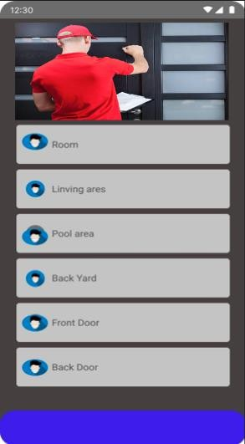

Mobile App 3

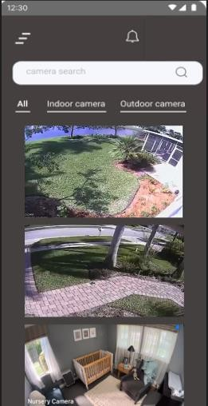

Mobile App 4

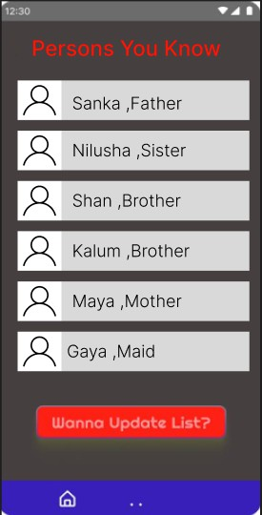

Mobile App 5

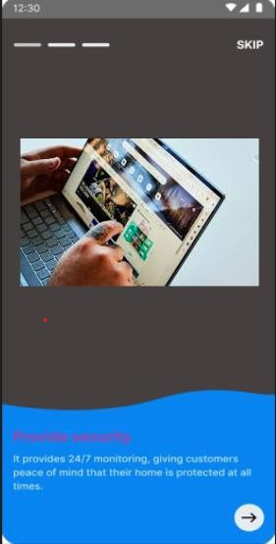

Mobile App 6

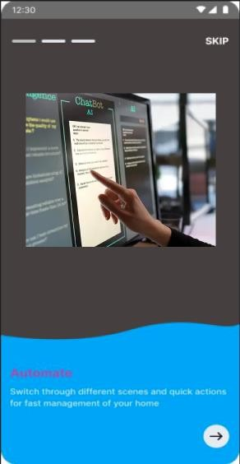

Mobile App 7

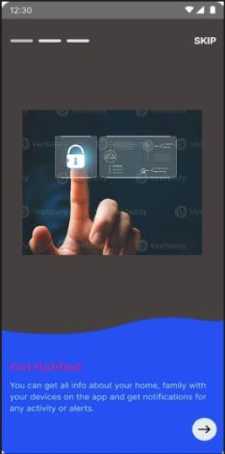

Mobile App 8

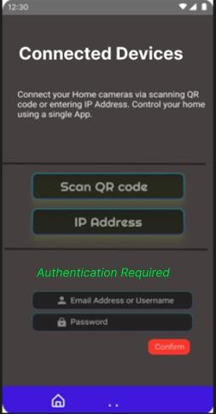

Mobile App 9

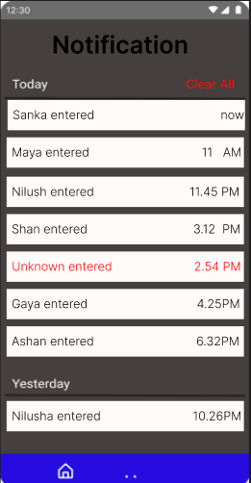

Mobile App 10

# IoT-based home security system feedback form and sample feedback

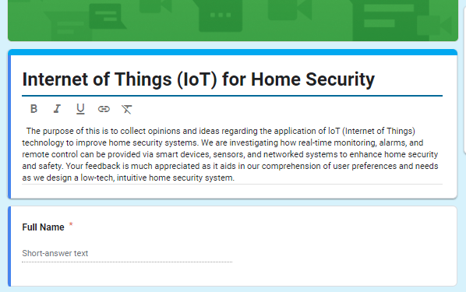

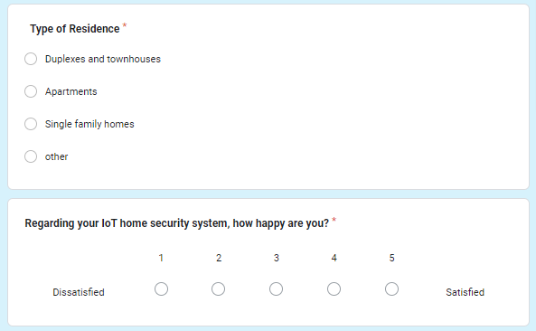

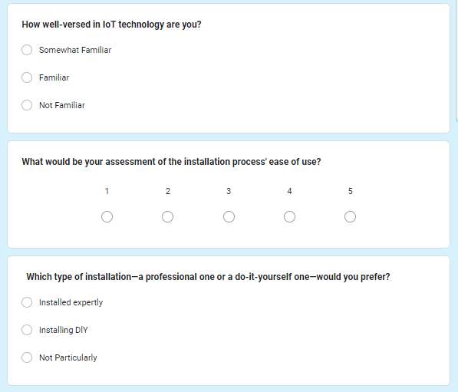

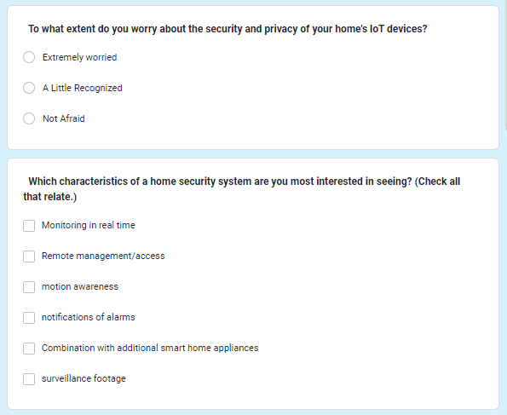

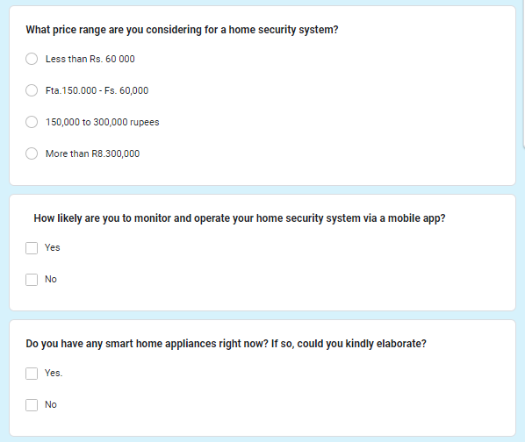

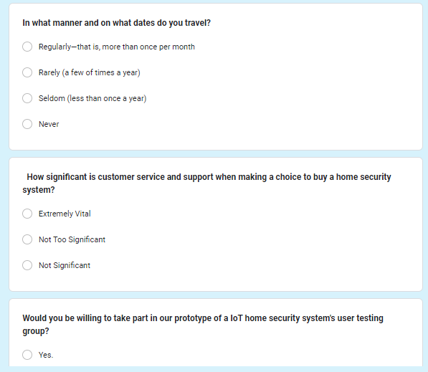

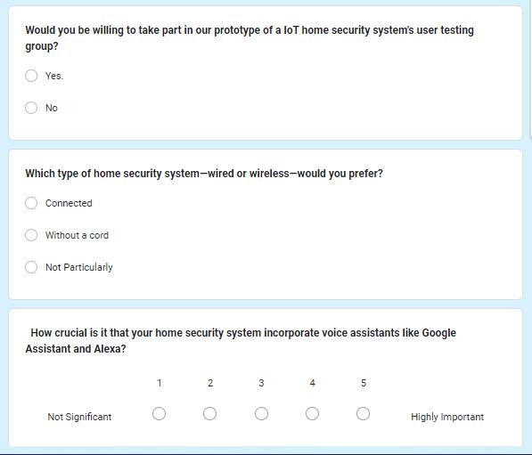

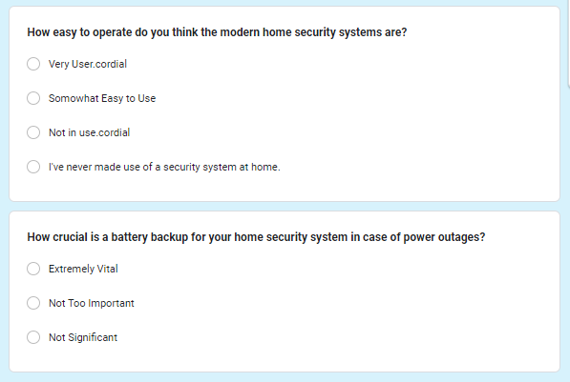

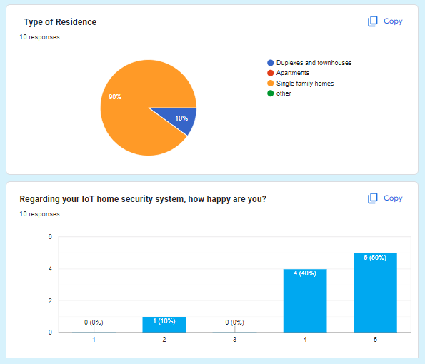

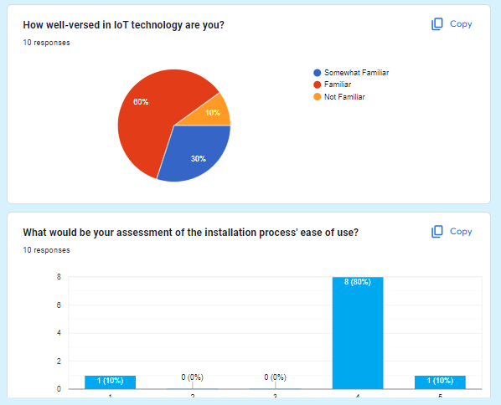

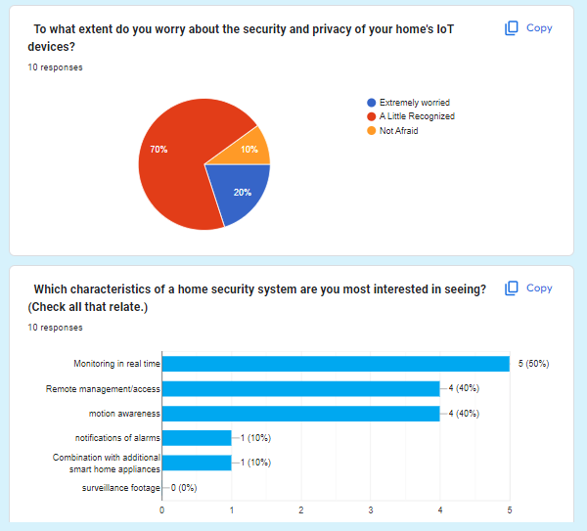

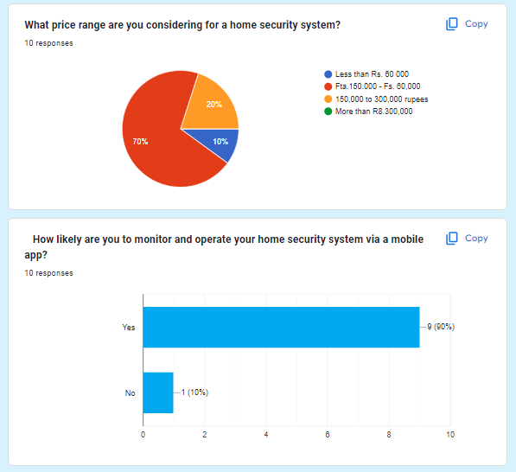

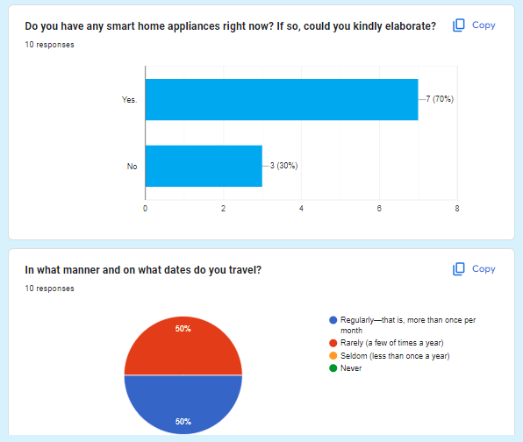

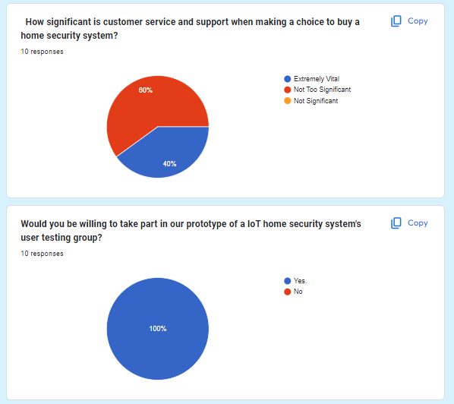

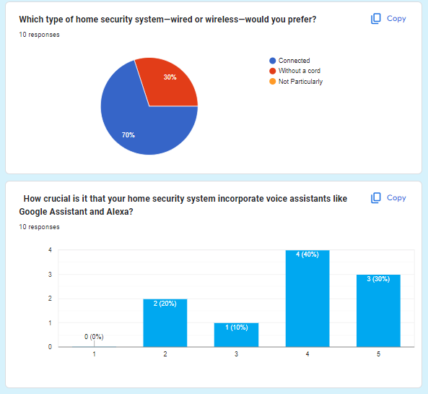

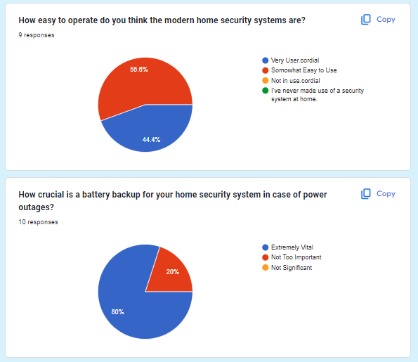

**Analyzing and Assessing End-User Comments**

The input received provides insightful information about the functionality and efficiency of the online courier management system at TravelBuddies.com. This is a review and analysis of the end-user comments.

# Analyzing Responses

**User Interface and Experience**

Positive Reactions

The user interface has typically been regarded by users as being clear and easy to use. Remarks regarding the arrangement, color palette, and design components show that the

interaction and visual designs are in good alignment with user expectations. This favorable response implies that the original design decisions were successful in producing a comfortable and approachable user experience.

Negative Reactions

Notwithstanding the encouraging comments, a few users said they had trouble navigating the menu. Although most users seemed to like the arrangement, some requested it be more simplified. This suggests that even if the interface has a pleasing visual design, there are still certain places where the navigation may be made better to make the user experience more seamless.

# Operational

Positive Reactions

The primary features—the monitoring and ticketing capabilities in particular—have received recognition for their usability. The simplicity and dependability of these features, which are essential for an online courier management system, were reported by users.

Positive feedback was also received by the complaint management system, as users expressed gratitude for its promptness and efficiency in resolving their concerns.

Negative Reactions

Nevertheless, there have been complaints of sporadic glitches during the reservation procedure, which might impair consumer satisfaction and possibly cause annoyance. Furthermore, a few consumers reported that they were occasionally left in the dark regarding the status of their consignments due to delayed delivery status updates. For the user experience to be flawless, these functional problems must be fixed.

# Achievement

Positive Reactions

According to reports, the system performs quickly and consistently, which is essential for preserving user happiness. The system's responsiveness suggests that, under typical circumstances, the underlying infrastructure is well-optimized for the majority of use cases, offering a seamless and effective user experience.

Negative Reactions

However, at busy hours, some users encountered delayed loading speeds. User happiness may be greatly impacted by this performance bottleneck, particularly if it happens

frequently. It is imperative to tackle these performance concerns in order to guarantee that the system maintains its dependability and speed even during peak usage.

# Support

Positive Reactions

One area of strength has been customer assistance, as customers have reported that the crew is friendly and quick to respond. The significance of having a dependable support system to help customers with their problems and questions is shown by this positive feedback, which raises user satisfaction levels.

Negative Reactions

However, a few individuals thought the FAQ section should have been longer. By offering quick and easily accessible solutions, a well-developed FAQ section may assist users in resolving common problems on their own, decreasing the need for direct support and improving the user experience overall.

# Extra Elements

User Recommendations

Users have contributed insightful ideas for new features that could improve the usability and performance of the system. Integration with well-known payment gateways is one such recommendation that would improve user ease and expedite the payment process. Another recommendation is to allow customers to bookmark their favorite addresses for easy bookings. This would expedite the booking process and enhance the user experience for frequent users.

# Assessment of Comments

Advantages

The system is satisfying user expectations in key areas, as evidenced by the good feedback about the user interface and main functionalities. The gratitude expressed for the complaint management system demonstrates how well it works to quickly resolve user concerns, which is essential for preserving satisfaction and confidence.

Limitations

Navigational challenges and sporadic glitches in the reservation procedure are major sources of concern. These problems may cause frustration and interfere with the user's experience. In a similar vein, problems with performance at peak periods might affect customer satisfaction and must be fixed to guarantee constant dependability.

Possibilities for Enhancement

By fixing the found flaws and adding user recommendations, there are obvious chances to improve the system. Navigation may be made easier by streamlining the menu and layout, and dependability can be increased by repairing faults and improving performance. Adding instructional films and enlarging the FAQ area can assist users in finding solutions on their own. Including further features like payment gateway integration and the ability to save preferred addresses will improve user convenience and satisfaction even more.

# Iterative Creation of the Internet of Things Application Using User Input

**Creating the Internet of Things App Iteratively**

The process of iterative development places emphasis on the iterative improvement of an application by means of repeated cycles of design, development, testing, and feedback. Because it enables developers to take user feedback into account at every step, this technique is especially advantageous for Internet of Things applications, as it guarantees that the program fulfills user expectations and demands. Through constant customer feedback during the development process, developers may make the program more dependable, functional, and user-friendly.

# Initial Development Phase

Making a working prototype of the IoT application is the main goal of the early development stage. Gathering requirements, creating an application, creating a functioning prototype, and doing initial testing are some of the crucial tasks in this phase. Gathering requirements is essential since it clarifies the essential features that users require.

Developing the application's fundamental architecture and layout is the focus of the design phase. The next step is development, where a prototype is constructed with the necessary characteristics. Lastly, preliminary testing is done to make sure the fundamental features operate as intended and to find any early problems that need to be fixed.

# Iteration 1: Improvement in Response to Input

When the first prototype is complete, consumers are asked to provide input. Based on these comments, the application is refined in the first iteration. The first step in this process is gathering user feedback on the prototype's functionality, usability, and design. After that, the input is examined to find recurring problems and potential areas of development. The application undergoes the appropriate modifications in light of this study. Bug fixes, UI element enhancements, and general user experience improvement are some examples of these modifications. This version makes sure that the program starts to meet user expectations and takes care of their early worries.

# Iteration 2: Performance Optimization and Advanced Features

After addressing the fundamental problems in the first iteration, the second iteration concentrates on enhancing the application's functionality and performance. Adding new features that were determined to be crucial during the first feedback phase is the focus of this phase. In addition to adding new features, a lot of work goes into performance optimization to improve the application's effectiveness and responsiveness. This guarantees that the program can manage higher loads and function properly in a variety of settings. In order to get input on the new features and performance enhancements, user testing is done once more. This allows for additional refinement depending on user insights.

# Complete User Feedback Integration in the Final Iteration

The ultimate version seeks to refine the application through the incorporation of extensive user feedback. This entails obtaining thorough input on every facet of the application from a broader user base. The input is utilized to fix any problems that still exist and guarantee that every feature is improved to satisfy user requirements. Comprehensive testing is also carried out during this phase to guarantee that the application satisfies all user needs and quality standards. The last version makes sure the program is stable, intuitive, and prepared for general usage, offering a dependable and fulfilling user experience.

# Summary

Iterative development makes sure that the Internet of Things application keeps improving based on ongoing input from users. By using this strategy, developers may produce a more dependable, user-focused product that better satisfies user demands, increasing user satisfaction and adoption rates in the process. This approach is perfect for the dynamic nature of Internet of Things applications since it not only aids in the early detection and correction of problems but also allows for the adaptation to changing user requirements.

The application is continuously developed through iterative development, leading to a final product that is in line with user expectations and market demands.

# Examining User Input and Talking About the Benefits and Drawbacks of the Techniques Employed

**Analysis of User Feedback**

Analyzing user feedback entails methodically compiling and evaluating user experiences and views regarding a good or service. Finding user demands, assessing strengths and shortcomings, and directing product improvements all depend on this process. A variety of methods, such as user testing, focus groups, surveys, interviews, and feedback forms, can be used to get input. The knowledge obtained from examining this feedback offers insightful guidance for raising customer satisfaction and making sure the product lives up to expectations. Maintaining a user-centered approach in product development and enhancement requires an ongoing process of understanding user feedback.

# Pros and Cons of the Applied Techniques

There are distinct advantages and disadvantages to various methods for evaluating user feedback analysis. Quick data collection from a broad audience can be accomplished via surveys and questionnaires; however, the quality of the questions and response rates determine how effective these methods are. Although they can be time- and resource- consuming, interviews offer in-depth qualitative insights and the chance for follow-up questions, which limits the sample size. Focus groups provide lively exchanges and a range of viewpoints, but group dynamics may sway individual beliefs, so careful moderation is required. human testing is expensive and frequently limited to particular test situations, but it provides for the direct observation of human interaction and the identification of usability concerns. Although feedback forms are user-friendly and simple to incorporate into the product, they

# Suggestions for Development

**Enhance Instructional Resources**

Improving training materials is essential to guaranteeing users can use the product effectively. The available resources could not be sufficient or difficult to comprehend. Creating interactive tutorials and videos, offering detailed instructions with images, and routinely upgrading the resources in response to user input are all necessary to make them better. These improvements will increase users' confidence and product proficiency by making learning more efficient and accessible.

# Boost the Stability of the System

One important factor in user happiness is system stability. The user experience can be greatly impacted by frequent crashes or slow performance. Thorough testing and debugging, strong monitoring and alerting systems, and performance-enhancing code and infrastructure optimization are all necessary to improve system stability. By taking these steps, system downtimes will be decreased and overall reliability will be increased, guaranteeing a better user experience.

# Enhance the Design of the User Interface

A satisfying user experience is largely dependent on a well-designed user interface (UI). The existing interface could be confusing or challenging for users to use. Simplifying the design, enhancing navigation, utilizing recognizable and understandable icons and labeling, and performing usability testing to get user input are all part of optimizing the user interface. By incorporating these enhancements, the interface will become more user- friendly and assist users in completing activities more quickly.

# Improve Notification Mechanism

A notification system that works well is crucial to informing consumers without becoming overbearing. It might be annoying for users to get too many or irrelevant notifications.

Adding more intelligent algorithms to the notification system, letting users alter its settings, and making sure alerts are clear and useful are all part of improving the notification system. With these improvements, alerts will be more beneficial and relevant, increasing user satisfaction and engagement.

# Increase the Capabilities of Real-Time Data

Extending real-time data capabilities is essential for users who rely on it to make decisions. This entails maintaining data integrity and dependability, supplying easily understood real- time dashboards, and modernizing the infrastructure to enable real-time data processing.

Robust real-time data capabilities enable consumers to make well-informed decisions quickly and efficiently, hence enhancing their entire product experience.

# Summary

Understanding customer demands and continuously developing the product depend on the analysis of user feedback. Every feedback analysis strategy has a unique mix of benefits and drawbacks, and the best approach will rely on the particulars of the situation. User

happiness and product quality can be greatly increased by putting recommendations like better training materials, increased system stability, optimized UI design, improved alerting system, and expanded real-time data capabilities into practice. The product will evolve in accordance with user expectations and market demands if a comprehensive and continuous approach to user input analysis is taken.

**LO4: Assess the challenges your IoT application may face in connecting with the larger IoT ecosystem.**

**Examining the Developed Internet of Things App**

**Synopsis of the Developed Internet of Things App**

The sophisticated system intended to improve the safety and security of residential properties is the created Internet of Things application for home security. A control hub, door/window sensors, cameras, motion detectors, and other smart devices are all incorporated into this application. Through an easy-to-use smartphone application, users can remotely monitor and control their home security. With this configuration, homeowners may enjoy increased protection and peace of mind thanks to real-time alerts, live video streaming, and remote control of the security equipment.

# Issues Solved by the Internet of Things Application

**Burglaries and Intruders**

The software offers live video feeds and real-time notifications to tackle the serious problem of break-ins and burglaries. The lack of instant notifications provided by traditional security systems may cause a delay in responding to a possible danger. When an unwanted entrance is discovered, the IoT application makes sure that users get immediate alerts on their mobile devices, enabling them to respond quickly. This feature makes it much easier to stop or lessen the effects of burglary.

# Remote Observation

The inability of traditional security systems to perform remote monitoring is one of their main drawbacks. When they are gone, homeowners frequently are unable to verify the status of their security equipment. This issue is resolved by the IoT application, which makes remote access possible via a mobile app. From anywhere in the globe, users can access live video feeds, monitor the condition of sensors, and get warnings. This feature allows for constant monitoring of the home's security, no matter where the homeowner happens to be.

# Combination and Management

Conventional security systems frequently have separate, autonomous devices that work in isolation from one another. There may be inefficiencies and security coverage gaps as a result of this fragmentation. The Internet of Things application increases overall effectiveness and efficiency by integrating several security devices into a centralized control system. Home security management is made easier for users by having a single interface to control all linked devices. All security components are guaranteed to be coordinated and to be fully covered by this integration.

# Inaccurate Alarms

False alarms are a frequent problem with many security systems, frequently brought on by outside influences or technological issues. False alarms on a regular basis might cause complacency and less reactivity to real threats. The Internet of Things application uses sophisticated algorithms and intelligent sensors to reduce the number of false alerts in order to solve this issue. By differentiating between actual security breaches and innocuous occurrences, these solutions guarantee precise and dependable alerts. The overall efficacy and trustworthiness of the security system are improved by this decrease in false alerts.

# Advantages of Internet of Things Use

Economical

The Internet of Things application eliminates the need for distinct security services by combining several features into a single system. In the long run, this consolidation saves money in addition to making home security monitoring easier. It is possible for homeowners to obtain complete security coverage without having to pay for several different, incompatible systems.

Friendly to Users

Because user experience was a priority throughout design, even non-techies could utilize the application. The system's usefulness and efficacy are maximized by users being able to explore and use it with ease thanks to its simple controls and intuitive interface.

The ability to scale

Because of its high scalability, homeowners may add more to their IoT home security system as their security requirements increase. The current system can easily accommodate new sensors and devices, giving it flexibility and adaptation to changing needs. Because of its scalability, the security system can grow with the needs of the homeowner.

Increased Safety

Home security is greatly enhanced by the IoT application's constant monitoring and rapid alarms. Because of the system's real-time detection and notification of possible threats, users are more vigilant and responsive, which lowers the probability of successful invasions.

Easy accessibility

The mobile application's remote access capability provides customers with an unmatched level of ease. It's easier for homeowners to keep informed and in control when they can easily monitor and operate their security system from anywhere in the world. This convenience is especially helpful for people with hectic schedules or frequent travel.

# Summary

The created IoT home security app provides a thorough and practical response to contemporary security issues. Through the resolution of important issues like breaches, insufficient remote surveillance, disjointed management, and false alerts, the program improves home security and homeowner comfort. It is an invaluable addition to any home security plan because of its many advantages, which include increased security, ease of use, affordability, and scalability. With the help of this Internet of Things application, home security has advanced significantly and homeowners can now properly safeguard their assets.

# Talking About Possible Integration Problems

**Problems with Compatibility**

Older Systems

There are frequently difficulties with integrating new software with existing, legacy systems. It's possible that these outdated systems don't support contemporary integration

standards, necessitating middleware solutions or extensive overhaul. Standards and Procedures

Integration issues can arise from inconsistent use of standards (such data formats like JSON vs. XML) and protocols (like HTTP, MQTT) amongst systems. It is necessary to carefully map and sometimes even transform data as it moves between systems in order to ensure compatibility.

Seller-Specific Adjustments

Complicating the integration process are systems with non-standard settings or bespoke features from various vendors.

The Technology Stack

Operating systems, databases, and programming languages are examples of different technological stacks on which different systems may be constructed. This discrepancy may result in compatibility problems, making it difficult for two systems to interact or function together.

# Safety issues

Observance

Integrated systems need to abide by a number of laws (such as HIPAA and GDPR). To avoid fines and other consequences, data handling procedures used by integrated systems must adhere to these criteria.

Breach of Data

System integration expands the area that could be attacked by malevolent parties. To avoid breaches, data storage and transmission across systems must be properly secured.

Deficiencies

Every system has a unique collection of weaknesses. In order to reduce risks, integration may occasionally reveal new vulnerabilities or exacerbate preexisting ones. Therefore, strong security measures and frequent upgrades are necessary.

Verification and Permission

It is essential to make sure that the authorization and authentication processes in integrated systems are reliable and safe. Unauthorized access may result from differences in user authorization or authentication processes.

# Scalability Problems

Balancing loads

It could be difficult to evenly distribute the load among interconnected systems. Inefficient load balancing can lead to underutilization of some systems and overburdening of others.

Degradation of Performance

When systems are integrated, each system may experience an increase in load. Performance may suffer if the systems are not built to manage the increased load, which could result in sluggish response times or outages.

Architecture that Scales

It is imperative to guarantee that both systems are engineered with scalability in mind. In order to accommodate growing demand, systems that were not designed for scale may need to be completely reengineered.

Allocation of Resources

It's critical to allocate resources (such as CPU, memory, and bandwidth) appropriately to meet growing demand. Reduced system performance and bottlenecks might result from ineffective resource management.

# Conclusion

There are many advantages to integrating systems, such as more functionalities, better data sharing, and simpler processes. But it also comes with a number of difficulties. To ensure smooth operation, compatibility issues necessitate careful preparation and sometimes substantial rework. Strong steps are required to protect data and ensure regulatory compliance due to security issues. To guarantee that systems can withstand growing demand without seeing a decline in performance, scalability concerns necessitate well considered architecture and resource management.

Organizations can accomplish successful integrations that improve their capabilities while upholding security, performance, and compliance standards by proactively addressing these problems.

# Evaluating the Completed Application in Relation to the Original Project Plan Overview of the Initial Project Plan

The original project plan acts as the project lifecycle's fundamental road map. It describes

the project's objectives, or the particular things the project is trying to accomplish. The project's scope is precisely defined to set limits on what can be included and cannot be included in the project. To make sure the project moves forward on time, a thorough timeline with important dates and milestones is supplied. Allocating resources is another essential element, outlining the material, financial, and human resources required for the project's successful completion. A risk management plan is also included to list potential hazards and provide mitigation techniques. A stakeholder analysis is also incorporated into the plan in order to identify all parties and comprehend their expectations and areas of interest.

# Overview of the Final Application

The product that was delivered once the project was completed is described in the final application overview. It provides a thorough explanation of the features and functionalities the program provides, outlining how it satisfies user requirements and project objectives. The application's design and usability are emphasized through the highlighting of the user interface (UI) and user experience (UX) features. The hardware and software requirements for the application are outlined in the technical specifications. Performance metrics are examined in order to evaluate the dependability, speed, and efficiency of the application.

# Disturbances from the Original Project Schedule

Disparities between what was initially intended and what was delivered are referred to as deviations from the original project plan. There are a number of reasons why these deviations could happen, including changes in stakeholder requirements, resource limitations, or technical difficulties. Scope creep is a common deviation in which features or requirements are added after the original plan was created. There are also a lot of timetable modifications that involve project schedule accelerations or delays. When there are discrepancies between anticipated and actual spending, budget variances arise. Shifts in the efficiency or availability of resources may cause changes in the allocation of those resources. Deviations may also result from technical problems that were not foreseen during the planning stage.

# Knowledge Acquired

The project's insights and expertise are captured in the lessons learned section, which is helpful for enhancing such projects in the future. The project's accomplishments are emphasized in this part, along with the things that worked well and ought to be done again in the future. The difficulties faced are addressed, as well as the methods used to overcome them. The project's best practices are disseminated to assist future projects with efficient plans and procedures. Based on the experience gained from the current project, suggestions are given for enhancements. These acquired lessons aid in averting previous errors and duplicating effective strategies in subsequent endeavors.

# Conclusion

The contrast between the completed application and the original project plan is summarized in the conclusion. It also contains a summary of findings that summarizes the key differences between the two. To determine whether the project has been successful in achieving its goals, an overall assessment is done. The prognosis is examined, taking into account the ramifications for upcoming initiatives and any necessary follow-up actions.

Ultimately, the conclusion provides a comprehensive assessment of the project's performance and areas for development by presenting broad reflections on the project's path and results.

You can efficiently compare the completed application with the original project plan, detecting deviations, documenting lessons learned, and offering a thorough evaluation of the project by carefully going over each of these subtopics.

# The critical assessment of the application's performance

Analyzing user comments, comparing the completed application to the original project plan, and pinpointing lessons learned are all important components of the critical evaluation of the program's performance. This is a summary based on the given document.

# Comparing the original project plan

Overview of the Initial Project Plan

Goals and Scope: Clearly stated project objectives and limits.

Timeline and Milestones: A thorough plan to guarantee prompt advancement.

Resource Allocation: Determining the precise amount of material, financial, and human resources required.

Risk management is the process of identifying possible risks and developing mitigation plans.

Identification of all parties involved and their expectations is known as stakeholder analysis.

# Overview of the Final Application

Features and Functionalities: A thorough rundown of the product that was provided, satisfying user requirements and project objectives.

The focus of user interface (UI) and user experience (UX) is on usability and design. Technical specifications: necessary software and hardware.

Performance metrics evaluate reliability, efficiency, and speed.

User feedback: End users' opinions and ratings are used to assess the overall success.

# Changes from the Original Plan

Introduced features or requirements beyond the original concept is known as scope creep. Timeline Modifications: Project timetable acceleration or delay.

Budget Variations: Disparities in actual and projected spending.

Changes in Resource Allocation: Modifications to the Efficiency or Availability of Resources.

Technical Problems: Unexpected difficulties that cause alterations.

# Analyzing User Input

**Positive Reactions**

Interface and Experience: Well-thought-out layout, color palette, and design components, with an intuitive and user-friendly layout.

Functionality: Essential functions like booking and tracking were highly praised. Performance: The system performs swiftly and dependable in general.

Support: A helpful and accommodating customer service staff.

# Negative reactions

Problems with Navigation: A few users said they had trouble navigating the menu.

Performance Issues: throughout busy hours, there are occasionally slow loading speeds and issues throughout the booking process.

Support Documentation: Several people thought the FAQ section should have included additional details. Knowledge Acquired

Successes include sensible first design decisions, dependable core features, and attentive customer service.

The challenges include intermittent problems, difficulties with navigation, and performance bottlenecks during peak hours.

Best Practices: Iterative development for continual improvement and incorporation of user feedback.

Suggestions include: fixing errors, improving navigation, speeding up the system, and adding more assistance materials.

# Conclusion

The project successfully produced a functioning and user-friendly application, but there were deviations from the original plan mainly because of scope creep, deadline modifications, and technological difficulties, according to a critical appraisal of the program's success. Through iterative development, the program has been refined thanks in large part to user feedback, which has addressed both positive and negative areas to improve overall user satisfaction. The project has taught us the value of consistent user involvement, thorough preparation, and flexibility in the face of unforeseen obstacles.

# References

[www.javatpoint.com.](http://www.javatpoint.com/) (n.d.). *Internet of Things Applications - Javatpoint*. [online] Available at: [https://www.javatpoint.com/internet-of-things-applications.](https://www.javatpoint.com/internet-of-things-applications)

Peerbits. (n.d.). *Exploring the Applications of IoT in Different Industries*. [online] Available at: https:/[/www.peerbits.com/blog/iot-applications-in-different-](http://www.peerbits.com/blog/iot-applications-in-different-) industries.html#:~:text=IoT%20devices%20and%20solutions%20can [Accessed 2 Aug.

2024].

Jena, S. (2020). *Architecture of Internet of Things (IoT)*. [online] GeeksforGeeks. Available at: <https://www.geeksforgeeks.org/architecture-of-internet-of-things-iot/>.

GeeksforGeeks. (2023). *Top 10 IoT Tools to Consider in 2023*. [online] Available at: [https://www.geeksforgeeks.org/top-iot-tools/.](https://www.geeksforgeeks.org/top-iot-tools/)

[www.tutorialspoint.com.](http://www.tutorialspoint.com/) (n.d.). *Internet of Things - Hardware - Tutorialspoint*. [online] Available at: [https://www.tutorialspoint.com/internet_of_things/internet_of_things_hardware.htm.](https://www.tutorialspoint.com/internet_of_things/internet_of_things_hardware.htm)

[www.hologram.io.](http://www.hologram.io/) (n.d.). *IoT APIs: A guide to Application Programming Interfaces*. [online] Available at: [https://www.hologram.io/blog/iot-apis-guide/.](https://www.hologram.io/blog/iot-apis-guide/)

Anon, (2023). *The Impact of the Internet of Things on Software Development - XAM - Software Development, React, .NET, Azure*. [online] Available at: [https://xam.com.au/the-](https://xam.com.au/the-impact-of-the-internet-of-things-on-software-development/) [impact-of-the-internet-of-things-on-software-development/](https://xam.com.au/the-impact-of-the-internet-of-things-on-software-development/).

Deakin University (2019). *Problem solving techniques: Steps and methods*. [online] Professional practice credentials. Available at: [https://credentials.deakin.edu.au/problem-](https://credentials.deakin.edu.au/problem-solving-techniques-steps-and-methods/) [solving-techniques-steps-and-methods/](https://credentials.deakin.edu.au/problem-solving-techniques-steps-and-methods/).

Jena, S. (2020). *Architecture of Internet of Things (IoT)*. [online] GeeksforGeeks. Available at: <https://www.geeksforgeeks.org/architecture-of-internet-of-things-iot/>.

News-Medical.net. (2022). *Investigating the Internet of Things Role in Forensic Investigations*. [online] Available at: [https://www.azolifesciences.com/article/Investigating-](https://www.azolifesciences.com/article/Investigating-the-Internet-of-Things-Role-in-Forensic-Investigations.aspx) [the-Internet-of-Things-Role-in-Forensic-Investigations.aspx.](https://www.azolifesciences.com/article/Investigating-the-Internet-of-Things-Role-in-Forensic-Investigations.aspx)

Yoo, C.S. (n.d.). *The Emerging Internet of Things*. [online] Centre for International Governance Innovation. Available at: https:/[/www.cigionline.org/articles/emerging-internet-](http://www.cigionline.org/articles/emerging-internet-) things/?utm_source=google_ads&utm_medium=grant&gad_source=1&gclid=Cj0KCQjwh7 K1BhCZARIsAKOrVqH0gFhKRDpqC7L6q_5Tq4FkrbrJoOlY5p4jQ5ausawLjn1RCTys1 VQaAvllEALw_wcB [Accessed 3 Aug. 2024].

Internet Society. (2019). *Internet of Things (IoT)*. [online] Available at: https:/[/www.internetsociety.org/iot/?gad_source=1&gclid=Cj0KCQjwh7K1BhCZARIsAK](http://www.internetsociety.org/iot/?gad_source=1&gclid=Cj0KCQjwh7K1BhCZARIsAK)

OrVqFTqjvqxXx7Cx12TEdX4XczL- NtT8jYzaBDDTLqHJt4_7wtt3zKZx0aAvGNEALw_wcB [Accessed 3 Aug. 2024].